|  |
| --- |
|  |
| *Training REPORT On 33/11KV Substation* |
| **Name: Shreya Mukherjee**  **Enrollment No:21UEI075**  **Year: 3rd Year(5th Semester)**  **Institute: National Institute ofTechnology, Agartala** |

West Bengal State Electricity Distribution Company Limited

**INDEX**

**Acknowledgement…………………………………0**

**1. Indian Power System……………………………3-7**

**2. WBSEDCL……………………………………....8-9**

**3. 33/11 kv Substation…………………………..10-65**

**4. Future Prospect………………………………..66**

**5. Data Analysis of Energy consumption of 33/11kv Liluah Substation…………………………………67**

**5. Conclusion……………………………………..67**

**6.Bibliography…………………………………….68**

# **ACKNOWLEDGEMENT**

**I would like to express my sincere gratitude to all the people who had been associated with me in some way or the other and helped me avail this opportunity for my Vocational Training on the topic**

**I am especially thankful to Mr. Jayanta Panda, Divisional Engineer of Howrah Division-I for providing me excellent guidance and motivation.**

**I am also thankful to the other officers for sharing their valuable experiences at the yard with the practical phenomenon.**

**Unit 1: Indian Power System**

**India is the third largest producer of electricity in the world. During the fiscal year (FY) 2022–23, the total electricity generation in the country was 1,844 TWh, of which 1,618 TWh was generated by utilities.**

**The gross electricity consumption per capita in FY2023 was 1,327 kWh. In FY2015, electric energy consumption in agriculture was recorded as being the highest (17.89%) worldwide. The per capita electricity consumption is low compared to most other countries despite India having a low electricity tariff.**

**The Indian national electric grid has an installed capacity of 416.0 GW as of 31 March 2023. Renewable energy plants, which also include large hydroelectric power plants, constitute 40.7% of the total installed capacity.**

**India's electricity sector is dominated by fossil fuels, in particular coal, which produced about three-quarters of the country's electricity. The government declared its efforts to increase investment in renewable energy. Under the government's 2023-2027 National Electricity Plan, India will not build any new fossil fuel power plants in the utility sector, aside from those currently under construction. It is expected that non-fossil fuel generation contribution is likely to reach around 44.7% of the total gross electricity generation by 2029–30.**

**1.1.** **Installed capacity**

**The total installed power generation capacity is the sum of utility capacity, captive power capacity, and other non-utilities which is 482.232 GW as on 31 March 2022.**

**1.1.1. Utility power**

**Nearly 32,285 MW coal and gas based thermal power projects are under construction as on 1 April 2021.**

**Hydroelectric power plants with ≤ 25 MW generation capacity are included in Renewable category (classified as SHP – Small Hydro Project).**

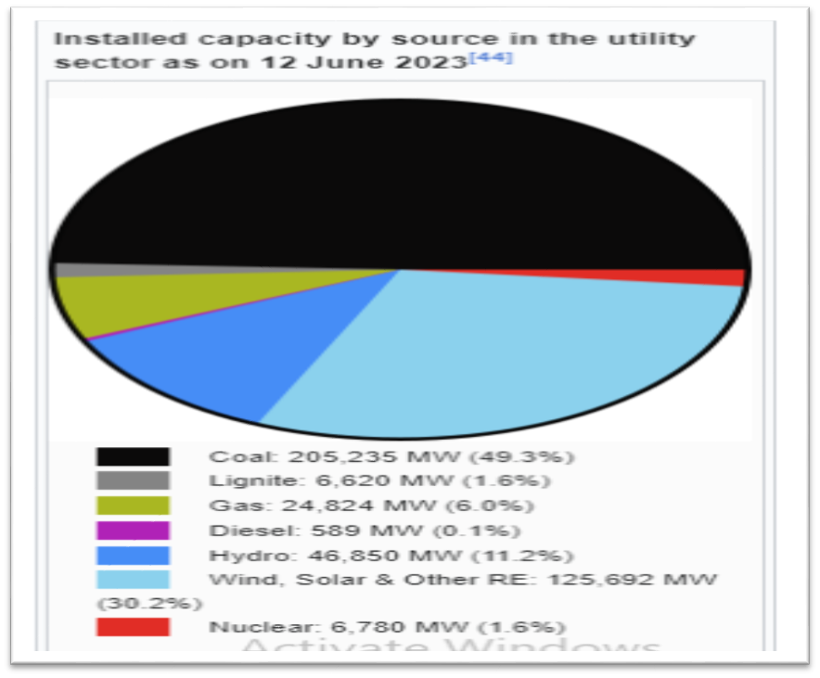

**1.1.2. Captive power**

**The installed captive power generation capacity (above 1 MW capacity) associated with industry-owned plants is 79,140 MW as of 31 March 2023. In the fiscal year 2022–23, captive power generation was 226,000 GWh. Diesel power generation sets of 75,000 MW capacity (excluding sets of size above 1 MW and below 100 kVA) are also installed in the country. In addition, there are a large number of diesel generators of capacity less than 100 kVA to cater to emergency power needs during power outages in all sectors.**

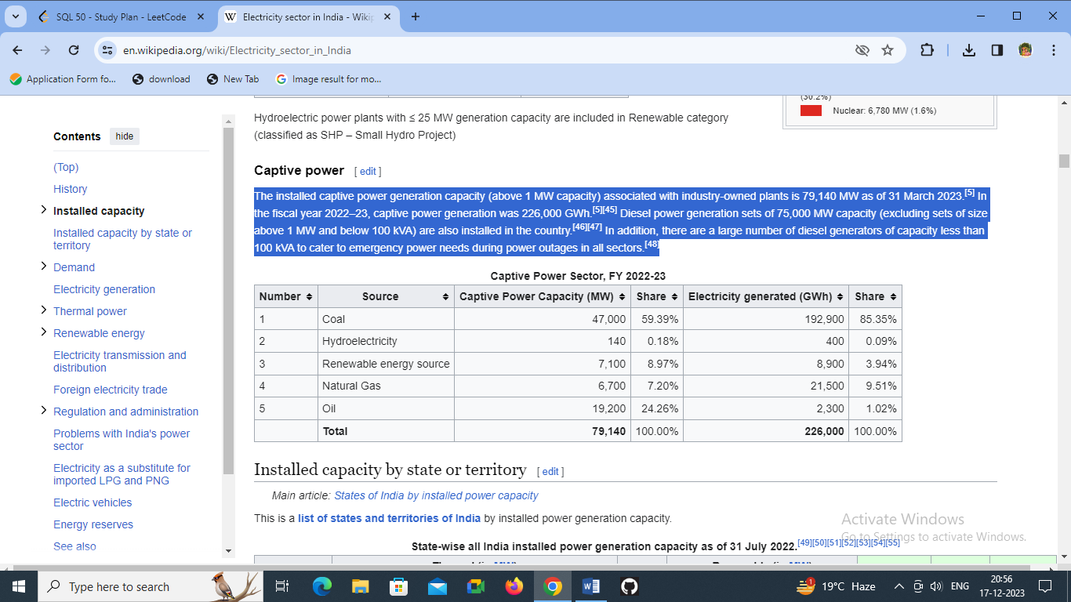

**1.1.3. Energy Sources**

**The Indian power system is a complex network that caters to the country's ever-growing demand for electricity. It relies on various energy sources, employs diverse generation methods, and utilizes an extensive infrastructure for distribution and transmission. This chapter delves into these components, highlighting their significance and challenges.**

**Energy Sources:**

**1. Coal:**

**Coal remains the primary energy source for electricity generation in India, contributing significantly to the power sector. Despite concerns about environmental impacts and emissions, coal-fired power plants continue to play a vital role due to their abundance and cost-effectiveness.**

**2. Renewable Energy:**

**India has made substantial strides in renewable energy adoption, particularly solar and wind power. The country's ambitious renewable energy targets aim to harness its vast solar potential and expansive wind resources, contributing to a cleaner and more sustainable energy mix.**

**3. Hydropower:**

**Hydropower, although a renewable energy source, faces challenges in implementation due to environmental considerations, land acquisition, and social impact concerns. However, it still holds promise in certain regions for generating electricity.**

**4. Nuclear Power:**

**India has a growing nuclear power capacity contributing to its energy mix. Despite challenges related to public perception, safety, and waste management, nuclear energy plays a role in the country's low-carbon energy strategy.**

**1.1.4. Structure of Indian Power System**

**The Indian power system is a complex network that involves the generation, transmission, distribution, and consumption of electrical energy across the country. It plays a crucial role in driving India's economic growth, supporting industries, and improving the quality of life for its citizens. The structure of the Indian power system is multifaceted, comprising various components that work together to ensure a reliable and efficient supply of electricity.**

1. **Generation: The power generation sector in India encompasses various sources such as thermal, hydroelectric, renewable, and nuclear power. Thermal power plants, primarily fueled by coal, contribute significantly to the country's electricity generation. However, India has been actively increasing its reliance on renewable energy sources like solar, wind, biomass, and hydroelectric power to diversify its energy mix and promote sustainability. Nuclear power plants also play a role in meeting the energy demands, albeit a relatively smaller one.**
2. **Transmission: The transmission network comprises a vast network of high-voltage transmission lines and substations that carry electricity from power generation facilities to load centers across the country. Power Grid Corporation of India Limited (POWERGRID) is the central transmission utility responsible for the inter-state transmission of electricity. State transmission utilities manage intra-state transmission. The National Grid connects different regional grids, ensuring the seamless exchange of power across the nation.**
3. **Distribution: Electricity distribution involves the delivery of power from the transmission network to end consumers. Distribution companies (Discoms) are responsible for this task. India has numerous Discoms operating at the state level. They manage the distribution infrastructure, including transformers, substations, and distribution lines, to supply electricity to homes, industries, commercial establishments, and other consumers.**

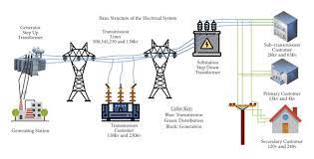

**Unit 2: West Bengal State Electricity Distribution Corporation Limited (WBDEDCL)**

**West Bengal State Electricity Distribution Company Limited (WBSEDCL) is a wholly owned enterprise of Government of West Bengal, established in 2007 as one of the two successors of West Bengal State Electricity Board, and is responsible for providing power to 96% of West Bengal with a customer base of more than 2.2 crore across the state. The company has achieved a profit of ₹95.13 crore (US$12 million or €12 million) (PAT) in the fiscal year 2010–11.**

**It states its Vision 'To Be The Best Power Utility In India In Terms Of Customer Service, Efficiency And Financial Viability' while its Mission to "Supply Uninterrupted and Quality Power to All”.**

**It is expanding the range and quantity of uninterrupted electric supply in the remote villages in rapid speed.**

**2.1.1 Introduction**

**The Government of West Bengal unbundled the erstwhile West Bengal State Electricity Board (WBSEB) into two companies viz., West Bengal State Electricity Distribution Company Limited (WBSEDCL) and West Bengal State Electricity Transmission Company Limited (WBSETCL). The main business of WBSEDCL is distribution and hydro generation of electricity. It is also the Nodal Agency of the Government of West Bengal for undertaking the Rural Electrification task in the State with the objective of providing access to electricity to all rural households in the state in line with the National Rural Electrification Policy.**

**The Company is managed by a Board of Directors comprising twelve members out of which seven are Executive Directors including Chairman & Managing Director. Besides one Woman Director and four Independent Directors constitute the Board.**

**WBSEDCL provides quality power to a gargantuan customer base of more than 2.03 crore across West Bengal through its service network spanning 5 Zones, 20 Regional Offices, 76 Distribution Divisions and 534 Customer Care Centers.**

**These are indeed exciting times for the Company, given its rapid progression from providing engineering solutions, to solving complex customer challenges, to providing innovative solutions. WBSEDCL has implemented Enterprise Resource Planning – SAP in Financial Accounting & Control, Material Management, HR with Payroll, Plant Maintenance and Project System.**

**After the successful implementation of the Purulia Pumped Storage Project in the 10th Plan period with a capacity of 900 MW hydel power, the company has taken up the ambitious plan of implementing the Turga Pumped Storage Project in the 13th Plan period with an installed capacity of 4 x 250 MW.**

**For solving complex customer challenges and for providing more efficient service to the consumers, a Project titled Integrated Power Development Scheme for strengthening of sub transmission and Distribution networks, metering of Distribution transformers etc. in the urban areas has been undertaken. A programme for system improvement under Sech Bandhu Scheme has also been conceived for rural areas.WBSEDCL is innovating and embarking upon an IT-enabled system across the organisation to ensure greater engineering predictability and to position itself into the best utility in the country in terms of customer service, efficiency and financial viability**.

**Unit 3: 33/11 kv Substation**

**The substation would be a combination of switching, controlling, and voltage step-down equipment arranged to reduce sub-transmission voltage to primary distribution voltage for residential, commercial, and industrial loads.**

**Power substation consists of:**

**1. Switch gears: Isolators, Circuit Breakers, earthing switches, etc**

**2.Control gears: Current Transformers, voltage transformers, contactors**

**3.Protection Equipment: relays, fuses, lightning arrestor**

**4. Power Transformers**

**3.1.1. Definition of Sub-stations:**

**The assembly of apparatus used to change some characteristics (e.g. voltage step up to step down or vice versa) of electric supply system is known as sub-station.**

**The electric power is produced at generating stations. It is delivered to the consumer ends through a large network of transmission and distribution. At many place in the line of supply system, it may be desirable to and necessary to change some characteristics (e.g. voltage step up to step down or vice versa) of electric supply system. This is accomplished by suitable apparatus called sub-station.**

**For example, generation voltage 11 KV at the generation station is stepped high to 132KV or 220KV for transmission and stepped down to 33 KV and further stepped down to 11KV for distribution.**

**3.1.2 Site selection for 33/11KV sub-station**

**Main points to be considered while selecting the site for Sub-Station are as follows:**

1. **The site chosen should be as near to the load center as possible.**
2. **It should be easily approachable by road or rail for transportation of equipment’s.**
3. **Land should be fairly leveled to minimize development cost.**
4. **The source of water should be as near to the site as possible. This is because water is required for various construction activities ;( Especially civil works,), earthling and for drinking purposes etc.**
5. **The sub-station site should be as near to the town / city but should be clear of public places, aerodromes, and Military / police installations.**
6. **The land should be have sufficient ground area to accommodate sub-station equipment’s, buildings, staff quarters, space for storage of material, such as store yards sand store sheds etc. with roads and space for future expansion.**
7. **Set back distances from various roads such as National Highways, State Highways should be observed as per the regulations in force.**
8. **While selecting the land for the substation preference to be given to the Govt. land over Private land.**
9. **The land should not have water logging problem.**
10. **The site should permit easy and safe approach to outlets for HV lines.**

**3.3****. Equipment’s in a 33/11KV substation:**

**3.3.1 Bus bar:**

**When no of feeders are operating at the same voltage have to be directly connected electrically, bus bar is used as the common electrical equipment. Bus bars are made of panther cable to operate at constant voltage. In sub-station it is important to break down and maintenance should be interfere as little as possible with continuity of supply, to achieve this high bus and low bus system are used**.

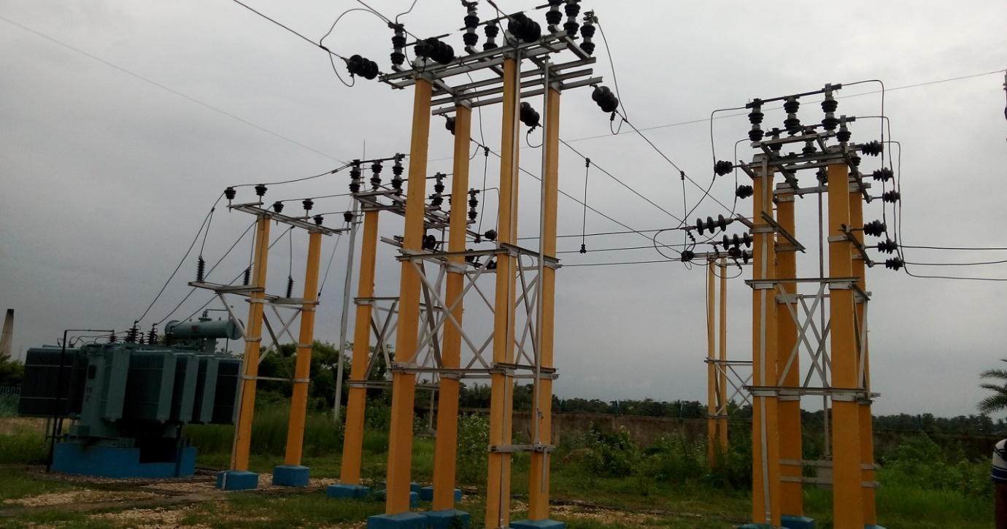

**3.3.2 Isolator:**

**Isolator is a mechanical switch which isolates a part of circuit from rest of the system. Circuit breaker always trips the circuit but open contacts of breaker cannot be visible physically from outside of the breaker. So for better safety there must be some arrangement so that one can see the open condition of the section of the circuit before touching it. There are different types of isolators available depending upon system requirement such as**

1. T.P.G.O.
2. C.R.T.

**3.3.3 Circuit breaker:**

**Electrical circuit breaker is a switching device which can be operated manually as well as automatically for controlling and protection of electrical power system respectively. Generally Vacuum circuit breakers are used in 33/11KV sub-station.**

**Types of Circuit Breaker Based on Interrupting Medium:**

* **Air Circuit Breaker: This circuit breaker will operate in the air; the quenching medium is an Arc at atmospheric pressure.**
* **Air Blast Circuit Breaker: Airblast circuit breakers are used for a system voltage of 245 kV, 420 kV, and also even more. Airblast circuit breakers are of two types:**

**Axial Blast Breaker: In the axial blaster breaker, the moving contact of the axial blast breaker will be in contact. The nozzle orifice is fixed to the contact of a breaker at a normally closed condition. A fault occurs when high pressure is introduced into the chamber. Voltage is sufficient to sustain high-pressure air when flowed through the nozzle orifice.**

* **SF6 Circuit Breaker:In the SF6 circuit breaker, the current-carrying contacts operate in sulfur hexafluoride gas is known as an SF6 circuit breaker. It is an excellent insulating property and high electro-negativity. It can be understood that, the high affinity of absorbing free electrons. The negative ion is formed when a free electron collides with the SF6 gas molecule; it is absorbed by that gas molecule. The two different ways of attachment of electron with SF6 gas molecules are**

**SF6 + e = SF6**

**SF6 + e = SF5- + F**

**The negative ions which are formed will be much heavier than a free electron. Therefore, when compared with other common gases overall mobility of the charged particle in the SF6 gas is much less. The mobility of charged particles is majorly responsible for conducting current through a gas. Hence, for heavier and less mobile charged particles in SF6 gas, it acquires very high dielectric strength. This gas good heat transfer property because of low gaseous viscosity. SF6 is 100 times more effective in arc quenching media than an air circuit breaker. It is used for both medium and high voltage electrical power system from 33KV to 800KV.**

* **Vacuum Circuit Breaker: A Vacuum circuit breaker is a circuit in which a vacuum is used to extinct the arc. It has dielectric recovery character, excellent interruption, and can interrupt the high-frequency current which results from arc instability, superimposed on the line frequency current.**
* **Oil Circuit Breaker: In this type of circuit, breaker oil is used, but mineral oil is preferable. It acts better insulating property than air. The moving contact and fixed contact are immersed inside the insulating oil. When the separation of current takes place, then carrier contacts in the oil, the arc in the circuit breaker is initialized at the moment of separation of contacts, and because of this arc in the oil is vaporized and decomposed in hydrogen gas and finally creates a hydrogen bubble around the arc.**

***3.3.3.1 Vacuum circuit breaker:***

**A vacuum circuit breaker is such kind of circuit breaker where the arc quenching takes place in vacuum. The operation of opening and closing of current carrying contacts and associated arc interruption take place in a vacuum chamber in the breaker which is called vacuum interrupter. The vacuum interrupter consists of a steel arc chamber in the center symmetrically arranged ceramic insulators. The vacuum pressure inside a vacuum interrupter is normally maintained at 10 - 6 bar.**

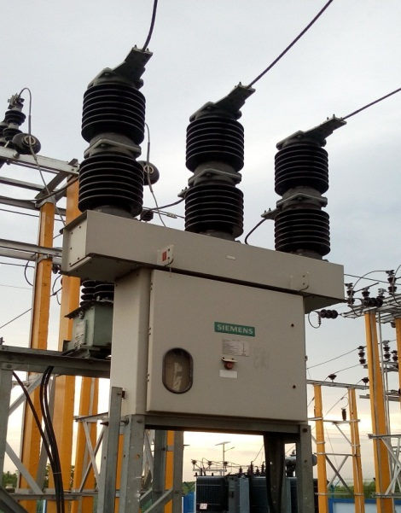 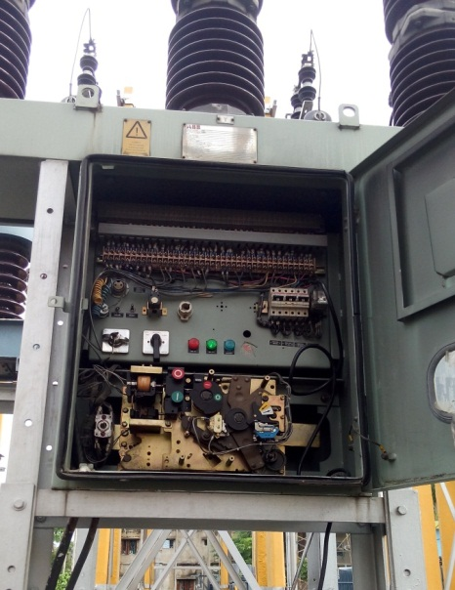

**Transient Operation:**

1. **Closing Operation:**
   * **Transient Recovery Voltage (TRV): When a VCB is closed to complete a circuit, there might be a transient recovery voltage across the contacts. This TRV can cause an arc to form if it exceeds the dielectric strength of the medium inside the VCB. The VCB needs to withstand and extinguish this arc quickly to ensure proper operation.**

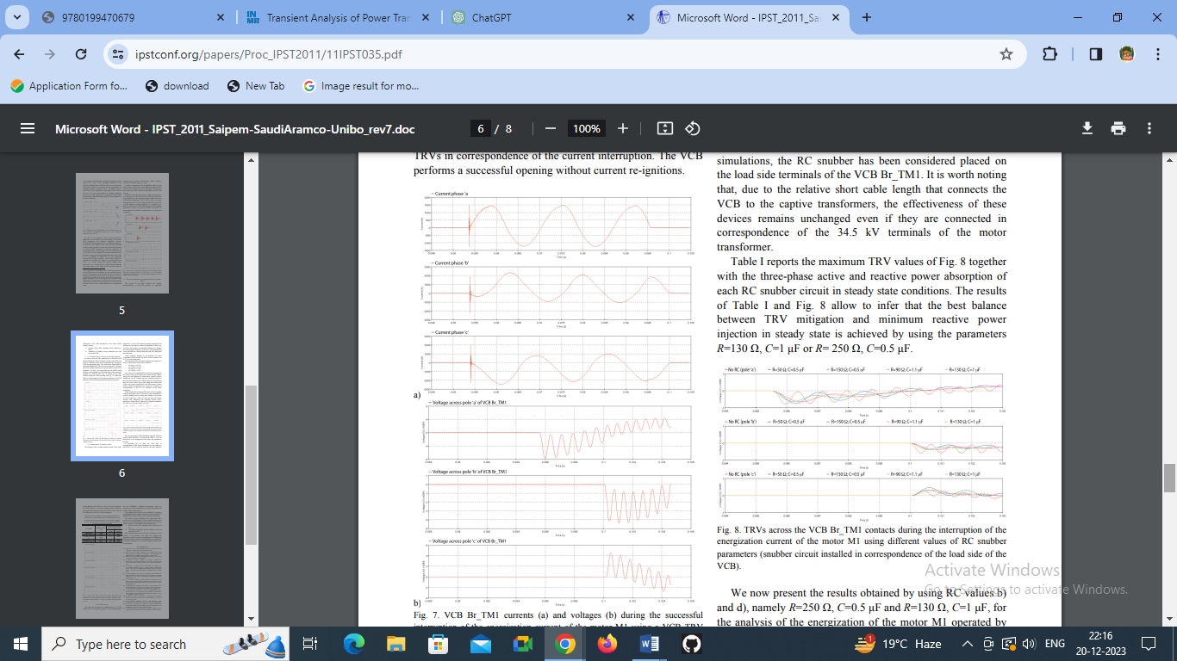

**Opening Operation:**

* + **Arc Extinction: During opening, the arc formed due to the current interruption needs to be extinguished efficiently. The VCB utilizes its design features (like contact material, geometry, and interruption mechanism) to quench the arc effectively.**

1. **Recovery Period:**
   * **Recovery Time: After interruption, there might be a time delay for the VCB to regain its dielectric strength and be ready for the next operation. This recovery period is essential to ensure the VCB's reliability for subsequent switching operations.**
2. **Transient Overvoltages:**
   * **Residual Transients: After interruption, there can be residual transient voltages and currents in the circuit. The VCB should be able to withstand or mitigate these transient overvoltages to prevent damage to the system or other connected devices.**

**Advantages of Vacuum Circuit Breakers**

1. **Vacuum circuit breakers does not require filling of any gas or oil. They do not need auxiliary air system, oil handling and free from periodic maintenance**
2. **Rapid recovery of very high dielectric strength on current interruption so that only half cycle or less arcing occurs after proper contact separation.**
3. **No emission of gases, hence pollution free**
4. **Current interruption occurs at first current zero after contact separation with no re-striking, making it exceptionally good for capacitor and cable switching and long line drooping**
5. **Non explosive and silent operation compared to air blast and SF6 breakers.**

**Disadvantages of Vacuum Circuit Breakers**

1. **Vacuum circuit breakers are uneconomical above 36KV and SF6 breakers having equivalent properties are economical. Hence for EHV (voltages above 230KV ) systems SF6 circuit breakers are employed**
2. **Loss of vacuum due to transit damage or failure makes the entire interruption useless and it cannot be repaired at site.**

**Specification of 33KV Vacuum Circuit Breaker:**

**Type= 36KV, 25KA**

**Voltage= 36KV**

**Current= 1250A**

**Frequency= 50Hz**

**No. of poles= 3**

**Breaking current= 31.5kAmps**

**Maker’s Rated Current =80kAmps**

**Short Circuit withstand current & duration= 31.5kAmps for 3secs**

**D.C. Component= 50%**

**BIL= 70/170KVp**

**Shunt Trip= 230 V (d.c.)**

**Mass= 900kg**

**Maker= ABB**

**3.3.4 Transformer:**

**In sub-stations two types of transformer are used.**

1. **Power transformer (33KV/11KV)**
2. **Station transformer (33KV/.44KV)**
3. **Instrument transformer**

***Power transformer:***

**Transformer is a static device by means of which electric power in one circuit is transformed into electric power of the same frequency in another circuit. The physical basis of a transformer is mutual induction between two circuits linked by a common magnetic flux. It consists of two inductive coils which are electrically separated but magnetically linked through a path of low reluctance. The first coil in which electrical energy is fed from the a.c. supply mains, is called primary winding and the other from which energy is drawn out, is called secondary winding.**

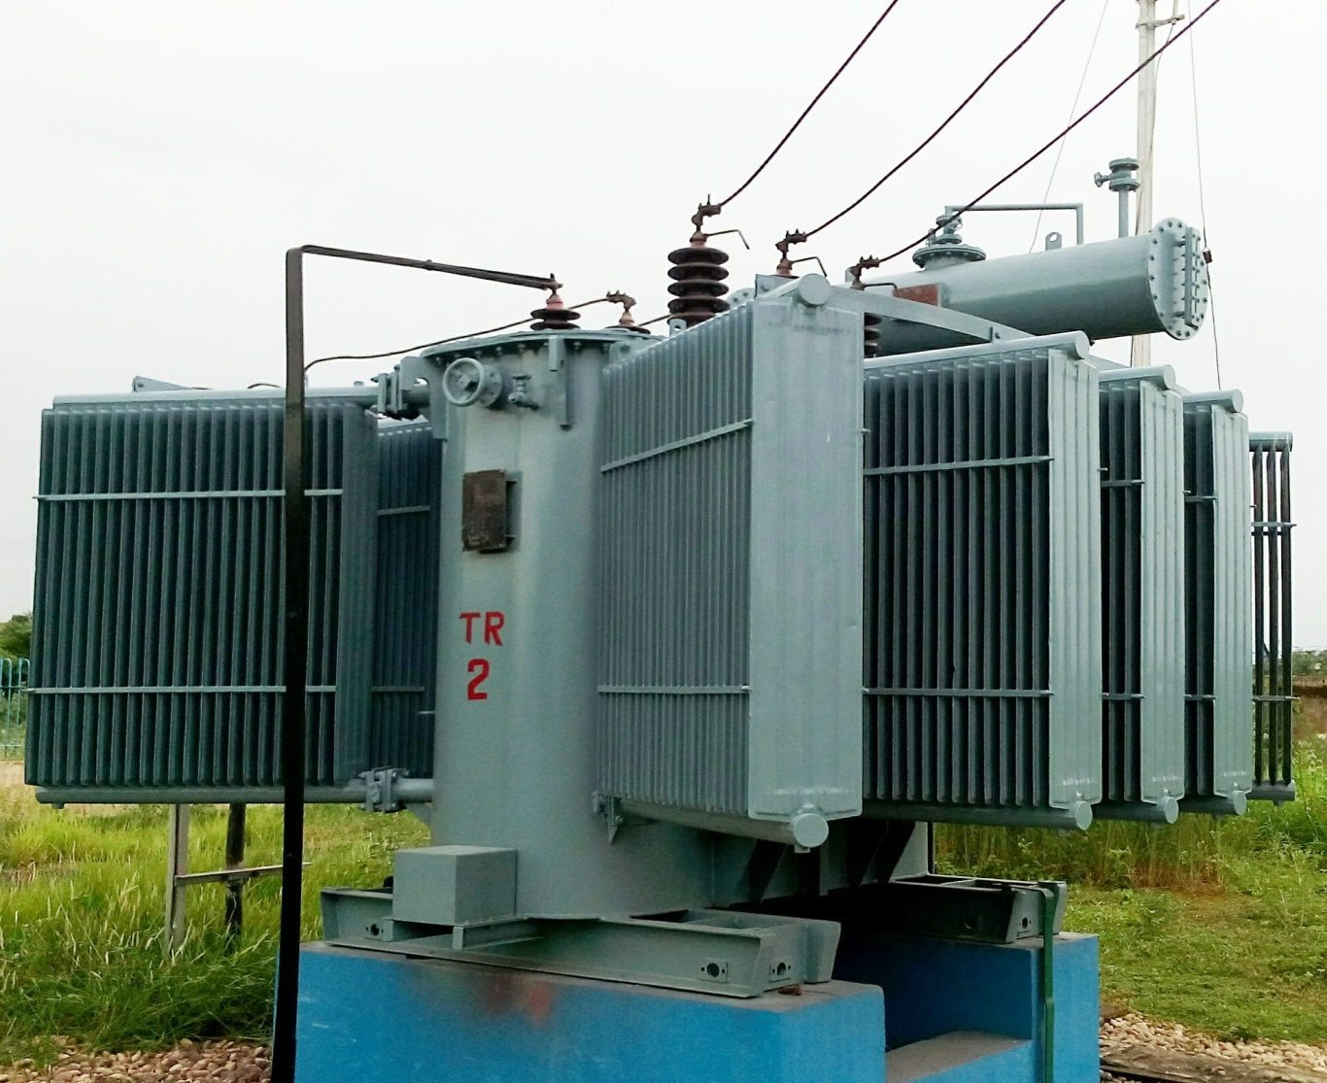

**As the system voltage goes up, the techniques to be used for the design, construction, installation, operations and maintenance also become more and more critical. The transformers used in sub-stations has delta/ star (∆/Y) connection.**

**Accessories of transformer:**

**Core & winding:**

**There are two general types of transformers, the core type and the shell type. The magnetic core is a stack of thin silicon-steel laminations. In order to reduce the eddy current losses these laminations are insulated from one another by thin layers of varnish. For reducing the core losses, the magnetic core made from cold-rolled grain-oriented sheet steel (C.R.G.O.). The core is placed at the bottom of the tank. The tanks are constructed from sheet steel for small tank & boiler sheet for large tank.**

**Transformer oil:**

**The tank is filled with transformer oil. It is a mineral oil obtained by refining crude petroleum. It serves the following purposes:**

1. **Provides additional insulation.**
2. **Cooling purpose.**

**Good transformer oil should have:**

1. **High flash point.**
2. **Free from inorganic acid, alkali and corrosive sulfur.**
3. **High dielectric strength.**

**It is important to check the oil in regular interval.**

**Conservator tank:**

**This is a cylindrical tank mounted on supporting structure on the roof of the transformer main tank. When transformer is loaded and when ambient temperature rises, the volume of oil inside the transformer increases. The conservator tank provides adequate space to this expand transformer oil and it also acts as a reservoir for transformer oil.**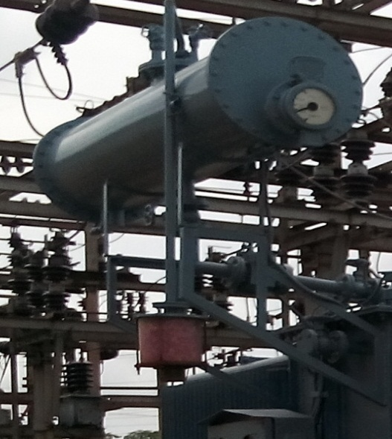

**Breather:**

**Whenever transformer is loaded, the temperature of the transformer oil increases, consequently the volume of the oil is increased and the air above the oil level in conservator will come out. When the oil temperature is low, the volume of the oil is decreased which causes air to enter into the conservator. The outside air always contains moisture which is very harmful for transformer insulation. A silica gel breather is used for filtering air from moisture. Silica gel breather is connected with conservator tank by means of breathing pipe. To remove the dust particle a pot is attached with breather end.**

**Radiator:**

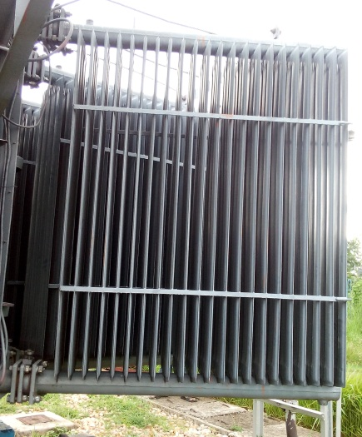**Under loaded condition, heat is produced in the winding which in turn increase the temperature of the oil. The warm oil increases in volume and comes to the upper portion of the main tank. Then this oil enters in the radiator through top valve and cools down by dissipating heat through the thin radiator wall. This cold oil comes back to the main tank through the bottom radiator valve.**

**Bushing:**

**It is fixed on the transformer tank and these connections are made to the external circuits. Ordinary porcelain insulators can be used as bushing up to voltage of 33KV.**

**Marshaling Box:**

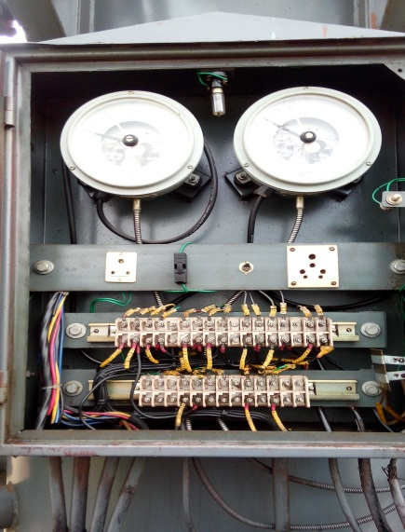**It has two meter which indicates the temperature of the oil and winding if the main tank. If temperature of oil or winding exceeds than specified value, relay operates to sound alarm. If there is further increase in temperature than relay completes the trip circuit breaker controlling the transformer.**

**PRV:**

**PRV (Pressure relief valve) is one of the protection components in the transformer. It is used to maintain inside pressure for the safety purpose. Its works automatically when inside pressure is out of limits.**

**Arcing horn:**

**It consists of two horn shaped metal rods separated by a small air gap. The horns are mounted on the porcelain insulators. On the occurrence of high voltage, arcing takes place across the gap & the arc travel up the gap. Consequently the arc is extinguished & the excess charge on the line is conducted to ground.**

**Buchholz relay:**

**It is a gas actuated relay installed in oil immersed transformers having rating more than 500KVa for protection against all kinds of internal faults. Such relays can only be fitted to the transformers equipped with conservator tanks as it is installed in between the conservator tank and transformer tank.**

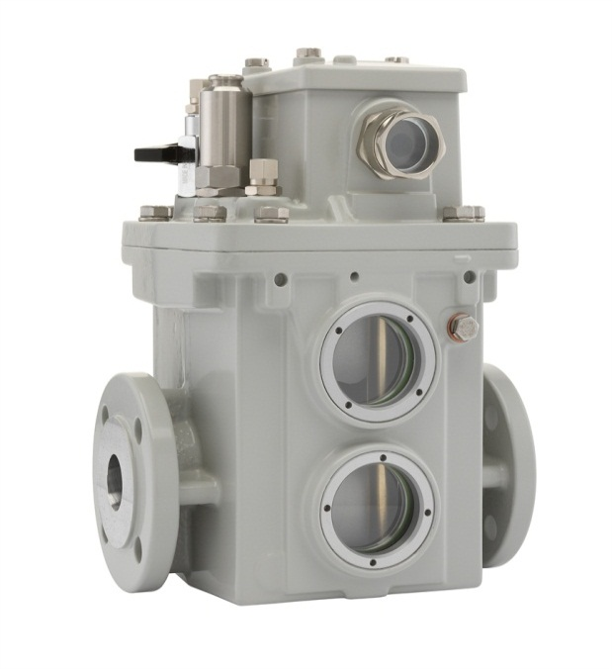 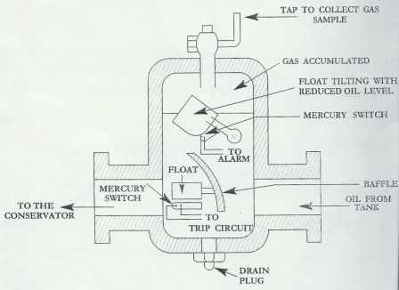

**It consists of two hinged float. The top float is connected with alarm circuit and the lower float is connected with the trip circuit. Whenever a fault occurs inside the transformer the oil of the tank gets overheated and gases are generated and collected in the chamber so the oil level gradually falls & closing the alarm circuit. I f no attention is paid to it, the gas collection will be more & closes another circuit which will cut out the transformer from the line.**

**OLTC:**

**In power transformer, for proper** [**voltage regulation of transformer**](http://www.electrical4u.com/voltage-regulation-of-transformer/)**, on load tap changer is required. As there is no permission of switching off the transformer during tap changing. The tapping arrangement is placed in separate diverter tank attached to electrical power transformer main tank. Inside this tank, the tap selectors are generally arranged in a circular form. The diverter switches have contacts operating in rapid sequence with usually four separate make and break units.**

|  |  |  |  |  |
| --- | --- | --- | --- | --- |
| **% of HV Turns** | **Tap Switch Position** | **Connections** | **HV Side Volts** | **LV Side Volts** |
| **+5** | **1** | **7 to 6** | **34650** | **11000** |
| **+2.5** | **2** | **6 to 8** | **33825** | **11000** |
| **N** | **3** | **8 to 5** | **33000** | **11000** |
| **-2.5** | **4** | **5 to 9** | **32175** | **11000** |
| **-5** | **5** | **9 to 4** | **31350** | **11000** |
| **-7.5** | **3** | **4 to 10** | **30525** | **11000** |
| **-10** | **7** | **10 to 3** | **29700** | **11000** |

**Specification of transformer:**

|  |  |  |
| --- | --- | --- |
| **MVA rating** | **6.3** | **10** |
| **Voltage at no load HV side/ LV side** | **33KV/11KV** | **33KV/11KV** |
| **Current at HV side/ LV side** | **110.25A/330.66A** | **175A/525A** |
| **Impedance voltage %** | **7.59** |  |
| **Frequency** | **50Hz** | **50Hz** |
| **Type of cooling** | **ONAN** | **ONAN** |
| **Vector group** | **Dyn-11** | **Dyn-11** |
| **Mass of oil** |  |  |
| **Total mass** |  |  |
| **Volume of oil** |  |  |
| **Maximum temperature rise in oil** | **50℃** | **50℃** |

***Station transformer:***

**Every sub-station has one station transformer. The station transformer is a 33KV/440volt transformer. It maintains the continuous power supply of sub-station.**

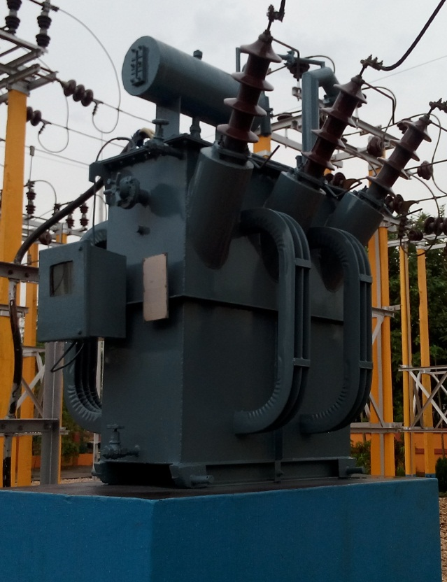 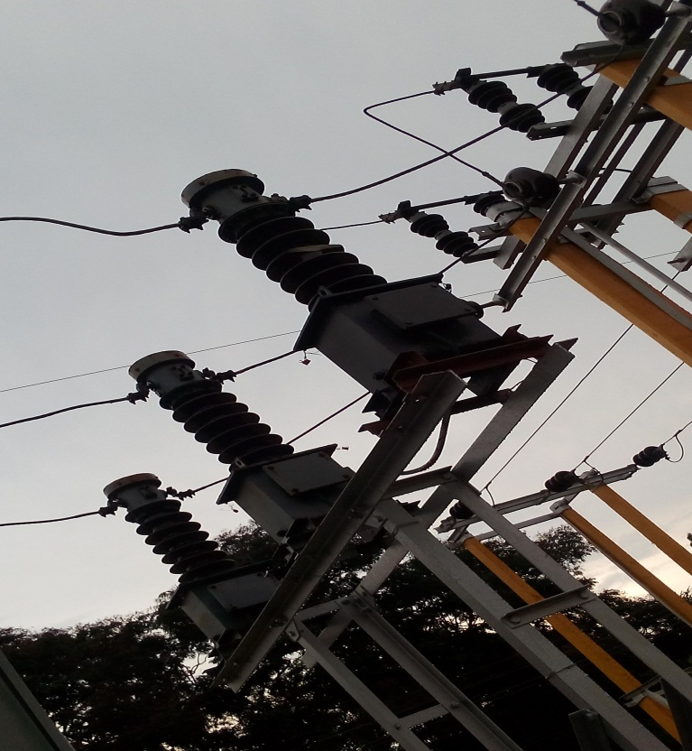

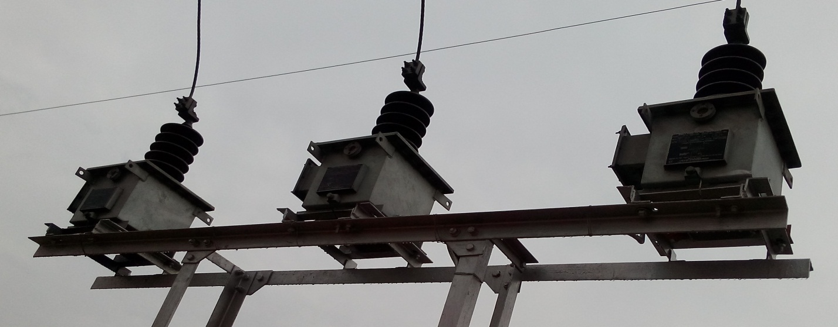

***Instrument transformer:***

1. **Current transformer:**

**Current transformers are basically used to take the readings of the currents entering the substation. This transformer steps down the current from 400 amps to 1 amp. This is done because we have no instrument for measuring of such a large current. The main use of this transformer is**

* + **Distance Protection**
  + **Backup Protection**
  + **Measurement**

***Transient Operation:*** **CT output is impacted drastically when the CT operates in the nonlinear region of its excitation**

**characteristic [1]. Operation in this region is initiated by:**

**• Large asymmetrical primary fault currents with a decaying dc component.**

**• Residual magnetism left in the core from an earlier asymmetrical fault, or field-testing, if**

**the CT has not been demagnetized properly.**

**• Large connected burden combined with high magnitudes of primary fault currents.**

**When the CT saturates because of the dc component, it can do so in the first few cycles of the**

**fault. Long dc time constant offset faults can cause CTs to saturate many cycles after a fault.**

**The fidelity of the transformation is reasonably good until saturation takes place. High-speed**

**distance or instantaneous overcurrent relays may operate before CT saturation occurs.**

**Equation 1 gives the instantaneous CT secondary current, is(t), as the sum of the instantaneous**

**burden, ib(t), and the magnetizing, im(t), currents*.***

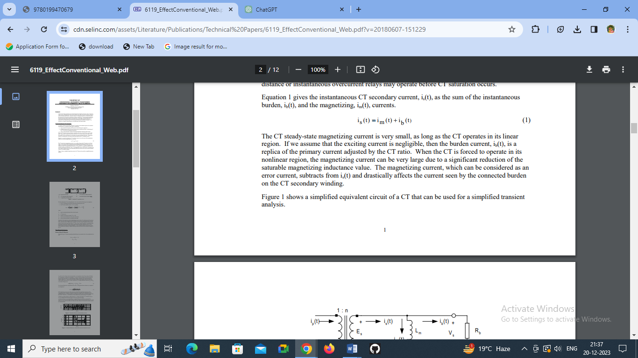

**The CT steady-state magnetizing current is very small, as long as the CT operates in its linear**

**region. If we assume that the exciting current is negligible, then the burden current, ib(t), is a**

**replica of the primary current adjusted by the CT ratio. When the CT is forced to operate in its**

**nonlinear region, the magnetizing current can be very large due to a significant reduction of the**

**saturable magnetizing inductance value. The magnetizing current, which can be considered as an**

**error current, subtracts from is(t) and drastically affects the current seen by the connected burden**

**on the CT secondary winding.**

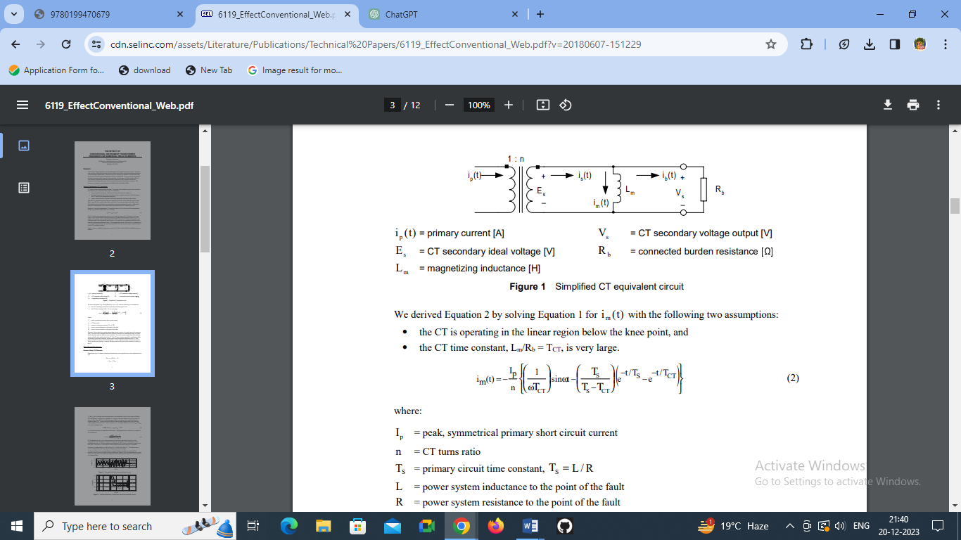

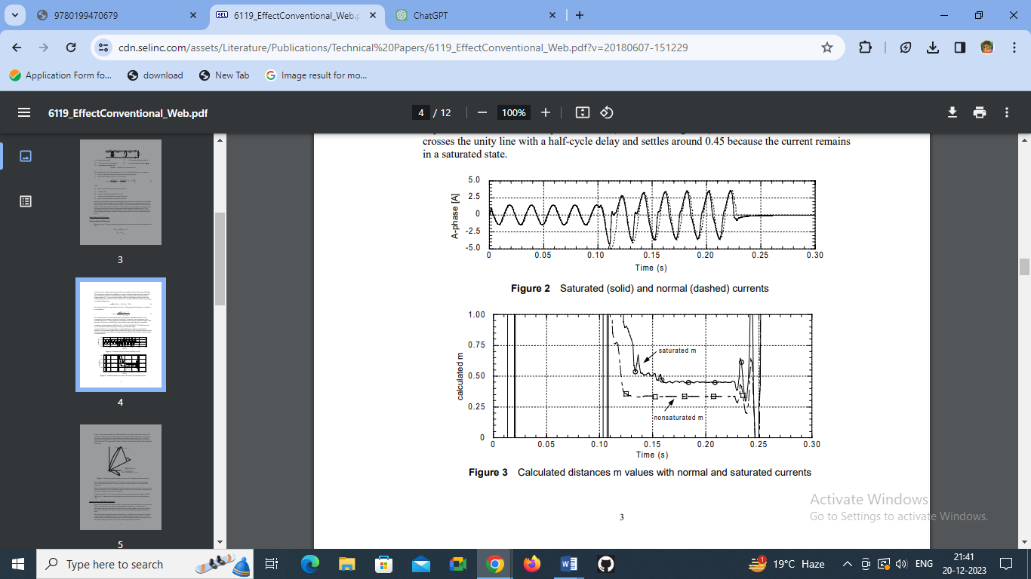

1. **Potential transformer:**

**There are two potential transformers used in the bus connected both side of the bus. The potential transformer uses a bus isolator to protect itself. The main use of this transformer is to measure the voltage through the bus. This is done so as to get the detail information of the voltage passing through the bus to the instrument. There are two main parts in it**

* + **Measurement**
  + **Protection**

***Transient Operation:***

**Transient analysis of a voltage transformer involves studying its behavior during sudden changes in voltage or when subjected to transients. One common transient scenario in a voltage transformer (VT) is a sudden increase or decrease in input voltage. Let's consider the transient response of an ideal VT to a step change in its input voltage.**

**Assumptions:**

* **Ideal VT with no resistance, leakage, or losses.**
* **Step change in input voltage at time t = 0.**

**The basic equation governing the transient response of the VT is based on the transformer's voltage ratio equation:**

***V*2/​*V*1​​=*N*2/​*N*1​​**

**Where:**

***V*1​ and *V*2​ are the primary and secondary voltages.**

* ***N*1​ and *N*2​ are the number of turns in the primary and secondary windings, respectively.**

**Let's assume a step increase in primary voltage *V*1​ from 0 to a new value *V*1*new*​​ at time =0*t*=0.**

**The equation for the step input is *V*1​(*t*)=*V*1*new*​​×*u*(*t*) Where *u*(*t*) is the unit step function.**

**From the voltage ratio equation: *V*2​(*t*)/*V*1​(*t*)​=*N*2​/*N*1​​**

**Since the transformer is ideal, the voltage across the secondary winding will also instantaneously increase according to the voltage ratio equation.**

***V*2​(*t*)=*N*1/​*N*2​​×*V*1*new*​​×*u*(*t*)**

**This shows that the secondary voltage also experiences a step change at time =0*t*=0 with a magnitude scaled by the turns ratio.**

**Now, to visualize this transient response, let's plot the input and output voltages of the VT.**

**Let's assume a turns ratio of *N*2​/*N*1​=1/10 and a step increase in primary voltage from 0V to 100V at =*t*=0. The secondary voltage will then change from 0V to 10V at *t*=0 as well.**

**3.3.5. Protective Relay:**

**A protective relay is a device that detects the fault and initiates the operation of the C.B. is to isolate the defective element from the rest of the system. The relay detects the abnormal condition in the electrical circuit by constantly measuring the electrical quantities, which are different under normal and fault condition.**

**Most of the relay operates on the principle of electromagnetic attraction or electromagnetic induction. The following important types of relays are used in 33/11KV sub-stations.**

**3.3.5.1 Digital Relays**

**Digital relays are a modern form of protective relays used in power systems to detect electrical faults and abnormalities. They utilize digital technology for their operation and offer more advanced features compared to traditional electromechanical or analog relays.**

**Around 1980s the digital relay entered the market. Compared to the , the digital relay takes the advantages of the development of microprocessors and microcontrollers. Instead of using analog signals.**

**In Digital Relay Microprocessors and micro controllers are used in replacement of analogue circuits used in static relays to . Digital protection relays introduced in 1980.**

**By the mid-1990s the solid state and had been mostly replaced by digital relay in new construction. In distribution applications, the replacement by the digital relay proceeded a bit more slowly.**

**While the great majority of feeder relays in new applications today are digital, the solid state relay still sees some use where simplicity of the application allows for simpler relays, and which allows one to avoid the complexity of digital relays.**

**Measuring Principles:**

**Compared to static relays, digital relays introduce Analog to Digital Converter of all measured analogue quantities and use a microprocessor to implement the protection algorithm.**

**The microprocessor may use some kind of counting technique, or use the Discreet Fourier Transform to implement the algorithm.**

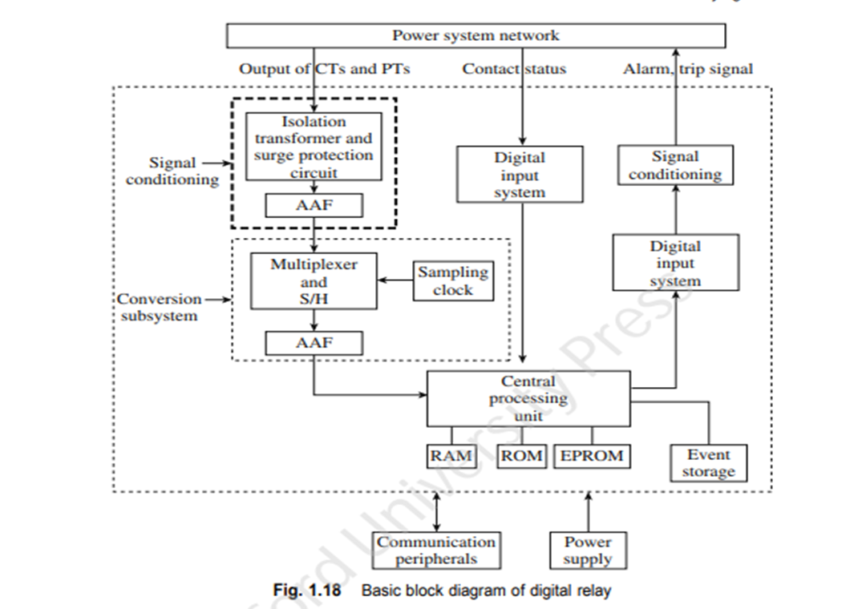 **Working Principle:**

1. **Signal Acquisition: Analog signals, such as currents and voltages acquired from the power system network, are processed by a signal conditioning device, which consists of isolation transformer, surge protection circuit, and anti-aliasing filter (AAF).**

* **Isolation transformer provides the electric isolation**
* **Surge protection circuit gives protection to the digital component against transients and spikes.**
* **AAF is a low pass filter that blocks the unwanted frequency component. Further, it also avoids aliasing error.**

**According to Nyquist criterion, the sampling frequency must not be less than two times the maximum frequency contained in original signal.**

**ƒs ≥ ×2 x ƒm**

**where, ƒs = sampling frequency and ƒm = maximum significant frequency within the signal sample, ƒo=frequency of the analog signal. It is to be noted that this processing is true if conventional transducers are used.**

**2. Digital Signal Processing (DSP):** **These input signals can be given directly to the central processing unit (CPU) if electronic CTs and CVTs are used. These signals are given to the CPU through multiplexer and analog to digital converter (ADC),which samples, combines, and converts the analog signal into digital form. The input signals are frozen by sample and hold circuit to achieve synchronized sampling between all the acquired signals. The digital input, such as status of circuit breaker contacts, status of local and remote end relays, and reset signals are acquired by the digital input system and transferred to the CPU.**

**3. Central Processing Unit:** **CPU is the core component of digital relay, where all processes regarding different logics/algorithm have been carried out. CPU executes the relay programme with a different characteristic, maintains different timing function, and communicates with external devices. Several memory units are allocated for data storage and data processing purposes.**

* **The random access memory (RAM) stores the input sample data temporarily and buffer data permanently. Further, the stored data in RAM is processed during the execution of relay algorithm.**
* **The read only memory (ROM) is used to store the relay algorithm permanently.**
* **EPROM is used to store certain parameters such as relay setting. These parameters may change in case of change in external system conditions.**
* **The event storage block is used for storing historical data such as fault related data, transient data, and event time data.**

**4. Decision Making:** **The digital output system provides the tripping, alarm, and other control signals to activate the external devices in the power system. A self-diagnosis software available in the digital relay checks integrity of the relay at regular intervals. This feature allows the relay to remove itself from service when a malfunction occurs and to alert the control centre.**

**5.Communication and Reporting: Relay setting, data uploading, and event data recording are done through the various peripheral communication ports. A common communication protocol IEC 61850 has been adopted by relay manufacturers to increase the interoperability of the relays among the local and remote substations. The digital relays are usually powered from the station battery, which is provided with a battery charger. This ensures that the relays will operate during outages of the station AC supply**

**Fundamentals of Digital Relays:**

**Sampling and Data Window:**

**Sampling:**

**The process of converting a continuous analog signal into a discrete-time signal is known as sampling. This**

**task is carried out by ADC along with sample and hold circuit. Certain fixed interval is used to acquire**

**the next (new) value of sample (quantity). This interval is known as sampling interval. The reciprocal of**

**sampling interval is referred to as the sampling frequency.**

**This entire process is known as sampling and quantizing. This can be obtained by two different approaches.**

**1. One approach is to acquire a sample at every sampling interval. In this approach, the necessary computations are carried out by algorithms before the next sample is acquired.**

**2. The other approach is to acquire a set of samples at a particular time, store them in a buffer, and thereafter, perform necessary computations by algorithms before the next set of samples are acquired.**

**Now, assuming the fundamental frequency of 50 Hz, the sampling frequency is given by**

**fs = f × n**

**where,**

**fs = sampling frequency (Hz)**

**f = fundamental frequency (Hz)**

**n = number of samples/cycle**

**Data window is the window having a set of acquired**

**samples that are used to obtain an estimate of the acquired**

**signal/quantity .The concept of data window, which uses three samples at a time in a window.It is to be noted that in each data window, the number**

**of samples remain constant (three samples in the case).**

**Therefore, when the next sample is acquired, the previous**

**sample is discarded. Whenever a new sample is taken, the**

**data window advances, that is, slides ahead. Hence, this**

**concept is also known as sliding window concept.**

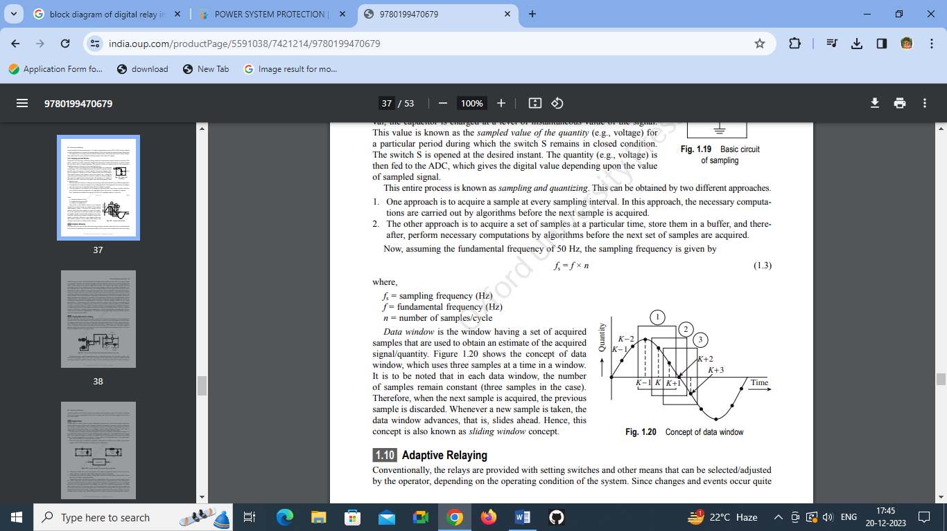

**Nyquist-Shannon Sampling Theorem: The Nyquist-Shannon theorem states that in order to accurately reconstruct a signal from its samples, the sampling frequency should be at least twice the maximum frequency component present in the signal of interest. Failure to meet this criterion leads to aliasing**

**ƒs ≥ ×2 x ƒm**

**where, ƒs = sampling frequency and ƒm = maximum significant frequency within the signal sample, ƒo=frequency of the analog signal.**

**Aliasing, Same Output, and Folding:**

* **Aliasing: When aliasing occurs due to undersampling, higher-frequency components alias or masquerade as lower-frequency components. This misrepresentation distorts the signal and leads to inaccuracies in the digital representation.**

***Formula for the Nyquist rate:***

***Nyquist Rate = 2 * Maximum Frequency Component in Signal***

***For example, if a signal has a maximum frequency component of 100 Hz, the Nyquist rate (minimum sampling frequency) should be at least 200 Hz to avoid aliasing*.**

* **Same Output: If the frequency of the input signal is equal to or less than half the sampling rate (according to the Nyquist theorem), the output after sampling accurately represents the input signal without distortion or aliasing.**

**ƒs = ×2 x ƒm**

* **Folding: Folding occurs when frequencies above the Nyquist frequency (half the sampling rate) appear as lower frequencies in the sampled signal due to undersampling. This results in these higher frequencies being folded or reflected back into the frequency range between 0 and the Nyquist frequency, causing distortion.**

**ƒs <2 x ƒm**

**In digital relays, maintaining an appropriate sampling rate is critical to ensure accurate representation of the electrical signals and to avoid issues related to aliasing, folding, and distortions. Adequate sampling rates help in preserving signal integrity and enable the relay to analyze and process the signals effectively for protection and control purposes in power systems.**

**Advantages**

* **Faster and more accurate fault detection and discrimination.**
* **Enhanced flexibility and configurability for different protection schemes.**
* **Improved reliability and reduced maintenance compared to electromechanical relays.**
* **Better communication capabilities for remote monitoring and control.**
* **Advanced features such as event recording, self-diagnosis, and fault waveform capture for post-fault analysis.**

**Limitation:**

* **Sampling Rate Limitations**
* **Quantization Errors**
* **Complexity and Sensitivity to Electromagnetic Interference**
* **Software and Firmware Vulnerabilities**
* **Relay Response Time**

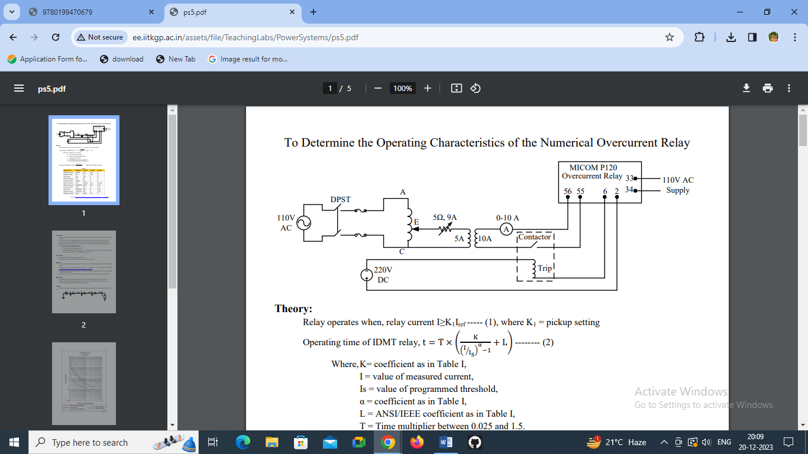**Numeric Overcurrent Type:**

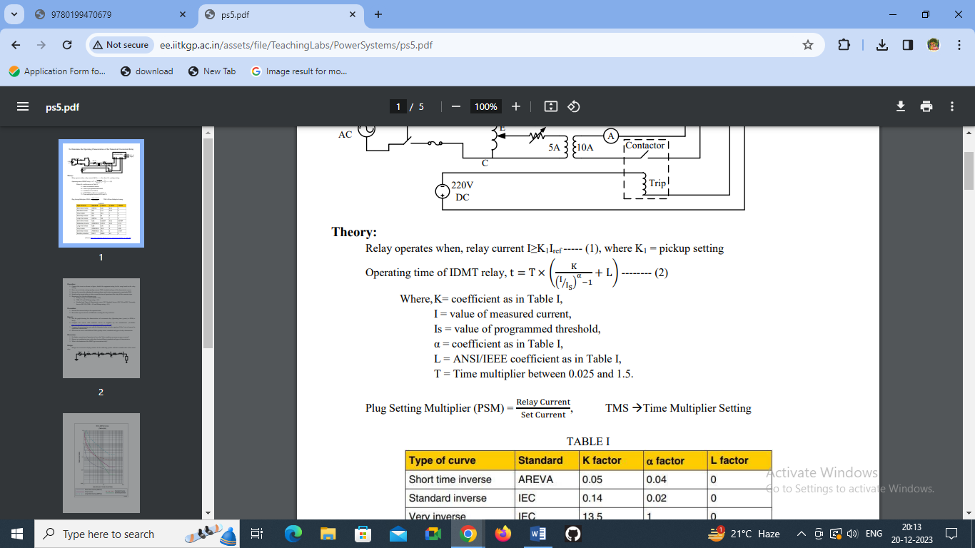

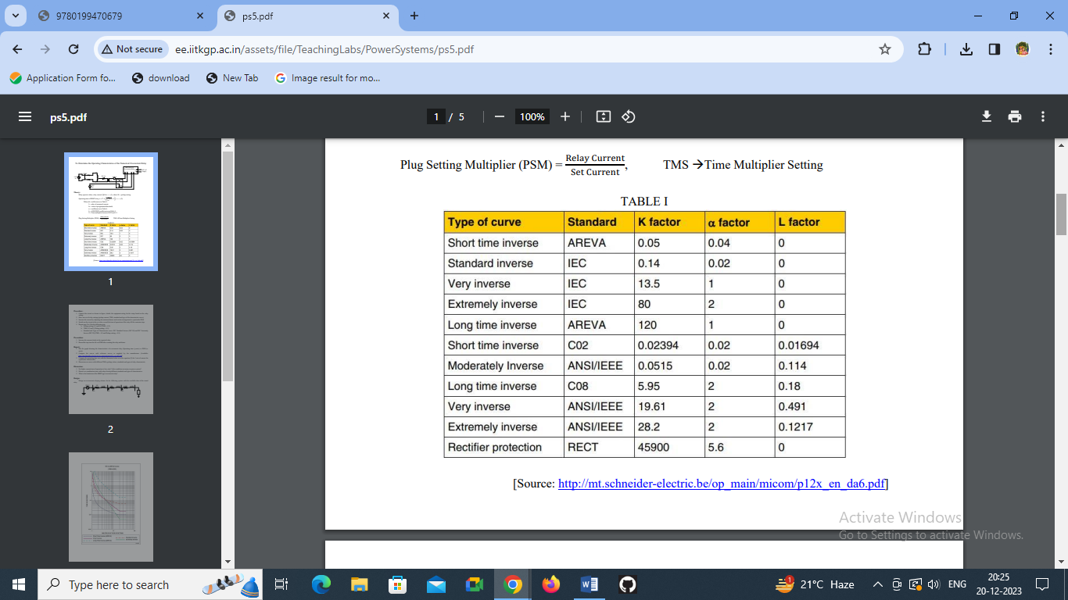

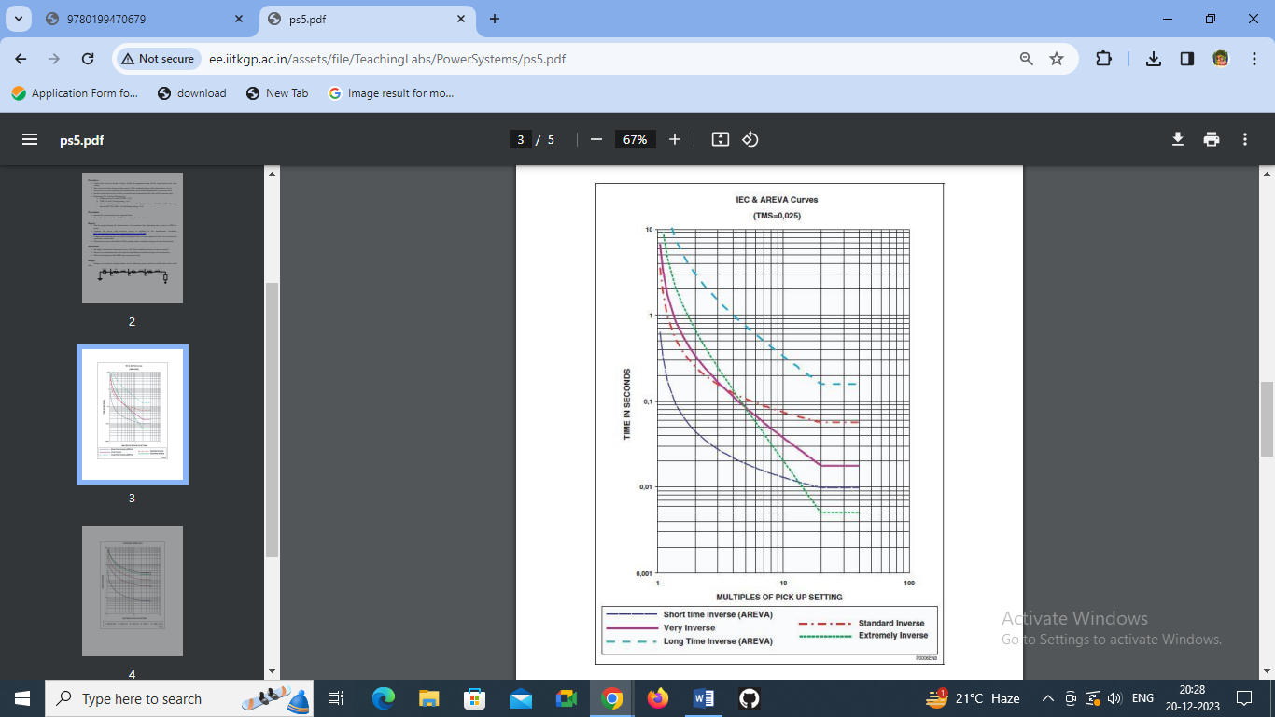

**Pin configuration of MICOM PI120 Overcurrent Relay**

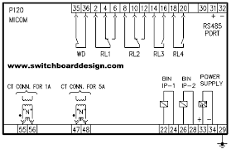

**Types of Relays:**

* **Induction type over current relay**
* **Differential Relay**
* **Earth fault relay**
* **Restricted earth fault relay**
* **Master trip relay**

***Instantaneous type over current relay:***

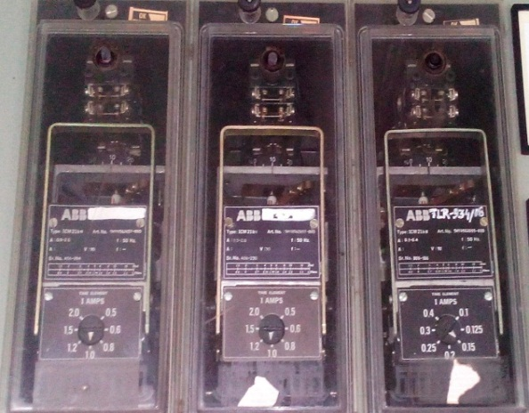**The over current relay responds to a magnitude of current above a specified value. There are four basic types of construction: They are plunger, rotating disc, static, and microprocessor type. In the plunger type, a plunger is moved by magnetic attraction when the current exceeds a specified value. In the rotating induction-disc type, which is a motor, the disc rotates by electromagnetic induction when the current exceeds a specified value.**

***Restricted earth fault relay:***

**An external fault in the star side will result in current flowing in the line current transformer of the affected phase and at the same time a balancing current flows in the neutral current transformer, hence the resultant current in the relay is therefore zero. So this REF relay will not be actuated for external earth fault. But during internal fault the neutral current transformer only carries the unbalance fault current and operation of Restricted Earth Fault Relay takes place. This scheme of restricted earth fault protection is very sensitive for internal earth fault of transformer. The protection scheme is comparatively cheaper than differential protection scheme.**

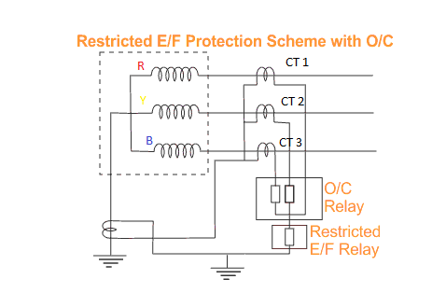

**Protection Scheme**

***Master trip relay:***

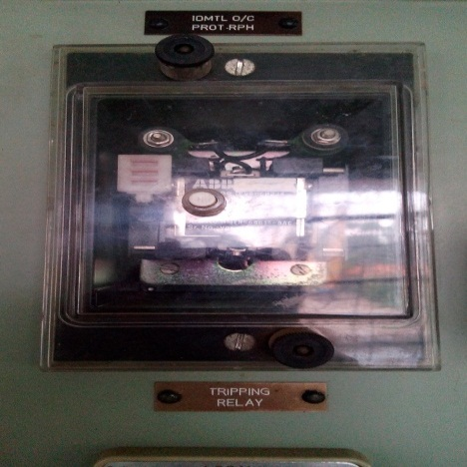**Master trip relay 86 is the main trip relay. The breaker will trip through this relay only. In transmission & distribution line there are so many protection relays like overcurrent relay, earth fault relay. All relay’s contact will connect parallel to master trip relay. If any of the protection relay sense the fault. It will energize the master trip rely and the master trip relay will trip the breaker. It got one more name like lock out relay.**

**Insulator:**

**There are mainly three types of insulator used in sub-station.**

1. **Pin Insulator**
2. **Suspension Insulator**
3. **Post Insulator**

***Pin type insulator:***

**As the name suggests, the pin type insulator is mounted on a pin on the cross-arm on the pole. There is a groove on the upper end of the insulator. The conductor passes through this groove and is tied to the insulator with annealed wire of the same material as the conductor. Pin type insulators are used for transmission and distribution of communications, and electric power at voltages up to 33 KV. Beyond operating voltage of 33 KV, the pin type insulators become too bulky and hence uneconomical.**

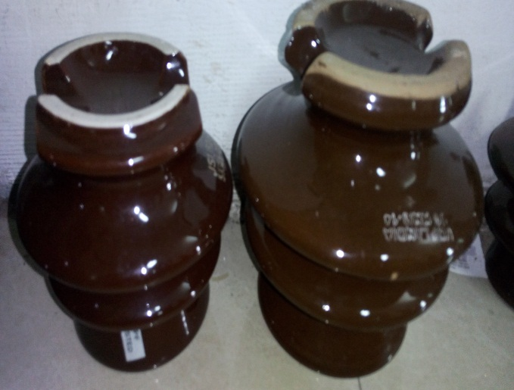 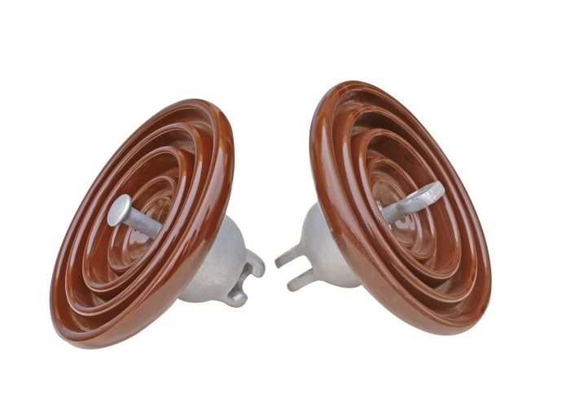

***Suspension insulator:***

**For voltages greater than 33 KV, it is a usual practice to use suspension type insulators, consisting of a number of glass or porcelain discs connected in series by metal links in the form of a string. The conductor is suspended at the bottom end of this string while the top end is secured to the cross-arm of the tower. The number of disc units used depends on the voltage.**

***Post Insulator:***

**Post insulator is more or less similar to Pin insulator but former is suitable for higher voltage application. Post insulator has higher numbers of petticoats and has greater height. This type of insulator can be mounted on supporting structure horizontally as well as vertically. The insulator is made of one piece of porcelain but has fixing clamp arrangement are in both top and bottom end.**

**Conductor specification:**

|  |  |  |  |
| --- | --- | --- | --- |
| **Conductor name** | **Area**  **(mm²)** | **Current carrying capacity**  **(Amp)** | **Application** |
| **Dog** | **100** | **260** | **High current transmission purposes** |
| **Panther** | **200** | **560** | **Bus** |

**Cable:**

**Cross-linked polyethylene, commonly abbreviated PEX or XLPE, is a form of polyethylene with cross-links.**

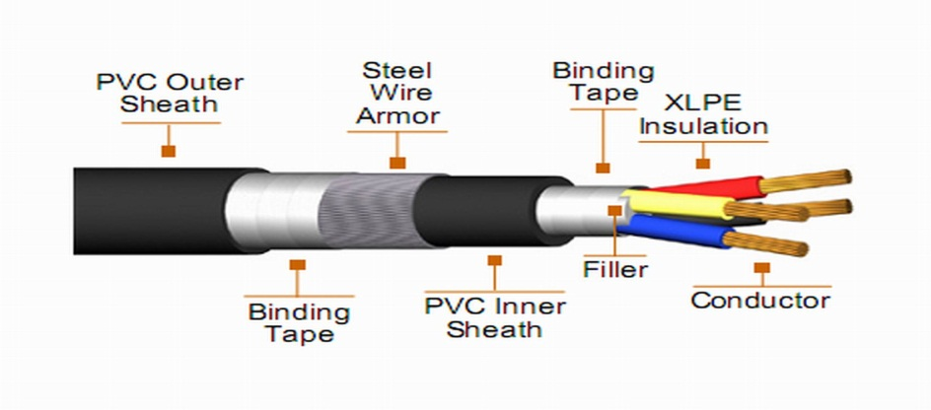

|  |  |  |
| --- | --- | --- |
| **Particular** | **Data** | **Data** |
| **Rated voltage** | **33KV** | **11KV** |
| **Highest system voltage** | **36KV** | **12KV** |
| **Short circuit current** | **1) 47.1 KA for 1Sec for 33 KV 500**  **sq.mm**  **2) 37.6 KA for 1Sec for 33 KV 400**  **sq.mm** | **1) 47.0 KA(895.47MVA) for 1 sec for 11KV 500 sq.mm**  **2) 37.6 KA (716.37MVA) for 1 sec for**  **11 KV 400 sq.mm** |
| **Maximum. Permissible short**  **circuit Temperature** | **250deg for 1 sec** | **250deg for 1 sec** |
| **Continuous withstand current** | **90deg** | **90deg** |
| **Material of conductor** | **Aluminum** | **Aluminum** |
| **Insulation** | **XLPE of thickness, 8.8 (Minimum) for 33 KV** | **XLPE of thickness, 3.6 mm. (Nominal) for**  **11 KV** |

**Lightening arrestor:**

**A lightning arrester is a device used on electrical systems to protect the equipment’s and conductors of the system from the effects of lightening. 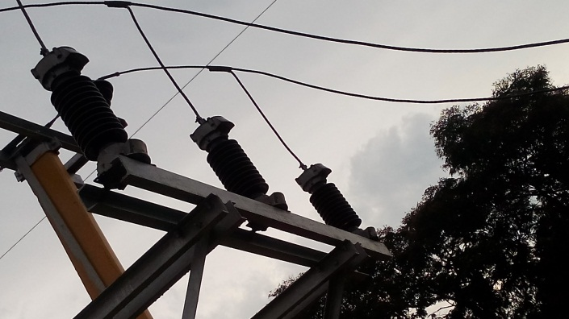The lightening arrestor can work in an angle of 45degrees around them. Metal oxide arrestors are used for lightening purpose. In normal case, it behaves like a high resistance path but when lightening occurs it behaves like a low resistance path. When lightening surge passes through this the surge is diverted through the arrestor to earth. The LAs employed for protecting transformers should be installed as close as possible to the transformer.**

**Substation Earthing System:**

**Earth mat:**

**In substation an earth mat is installed at places where a person or an operator would stand to operate a switch or apparatus. In the vicinity of electrostatic sensitive devices, an earth mat is used to ground the static electricity generated by equipment’s.**

**Bus Coupler:**

**The bus coupler consists of circuit breaker and isolator. Each feeder may be connected to either main bus bar or spar bus bar with the help of bus coupler. Repairing, maintenance and testing of feeder section can be done by putting them on spar bus bar, thus keeping the main bus bar undisturbed. Bus coupler is a device which is used to switch from one bus to another bus without any interruption in power supply and without creating hazardous arcs.**

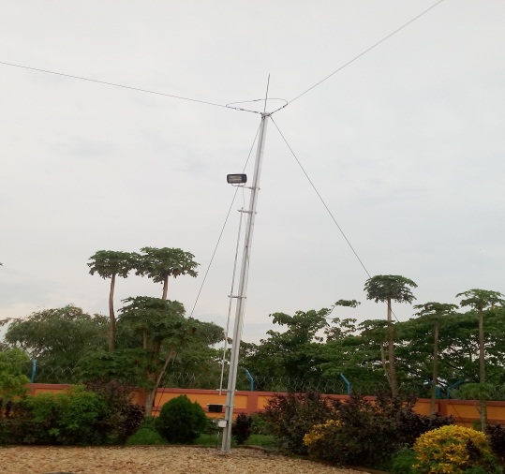**Overhead ground wires:**

**The most effective method of providing protection against direct lightning strokes is by the use of overhead ground wires. The ground wires are placed over the line conductors at such position that practically all lightning strokes are intercepted by them. The ground wire is ground at each tower through as low resistance as possible. When the direct lightning strokes occur on the line will be taken by the ground wire. The heavy currents flow to the ground through this wire.**

**D.C. battery source: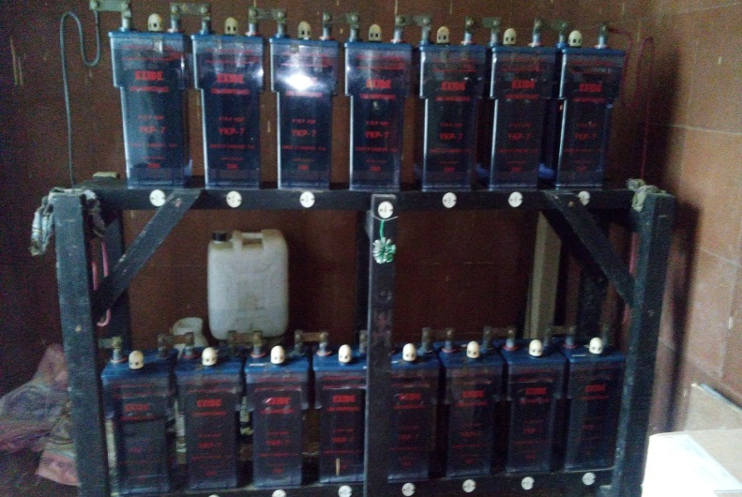The operation of monitoring devices such as relays and the tripping mechanism of breakers require an independent power source, which does not vary with main source being monitored. Batteries provide this power source for the successful operation of switching and control the device in sub-station. Each battery is considered 2.2 volt and 16 batteries are required to control the panel.**

**Control and Relay Panel:**

**The control and relay panel is of cubical construction suitable for floor mounting. All protective, indicating and control elements are mounted on the front panel for ease of operation and control. The hinged rear door will provide access to all the internal components to facilitate easy inspection and maintenance. 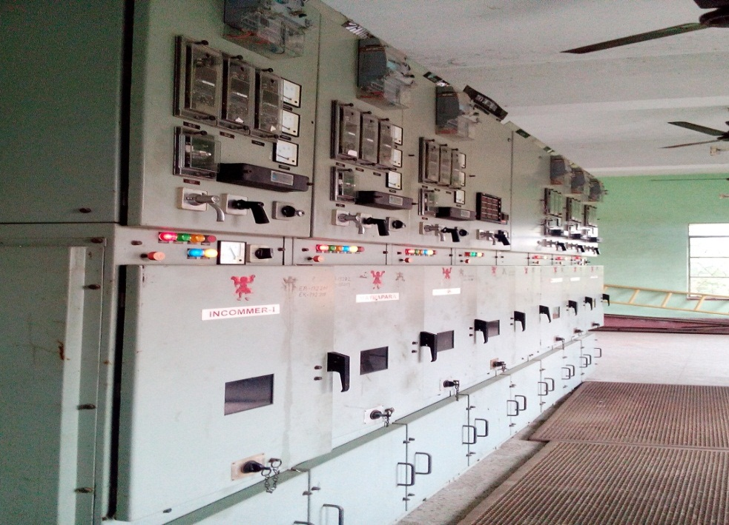Provision is made for terminating incoming cables at the bottom of the panels by providing separate line-up terminal blocks. For cable entry provision is made both from top and bottom. The control and relay panel accepts CT, PT aux 230 AC and 220V/10V DC connections at respective designated terminal points. 220V/10V DC supply is used for control supply of all internal relays and timers and also for energizing closing and tripping coils of the breakers. 230V AC station auxiliary supply is used for internal illumination lamp of the panel and the space heater. Protective HRC fuse are provided with in the panel. Breakers are provided with a line ammeter with selector switch for 3 phase system & over current relay (2 phases and 1 Earth fault for 3 phase system). Neutral Current Unbalance Relays are for both Alarm and Trip facilities breaker control switch with local/remote selector switch, master trip relay and trip alarms acknowledge and reset facilities.**

**3.4. Transformer protection:**

**Buchholz relay:**

**It is a gas actuated relay installed in oil immersed transformers having rating more than 500KVa for protection against all kinds of internal faults. Such relays can only be fitted to the transformers equipped with conservator tanks as it is installed in between the conservator tank and transformer tank.**

**It consists of two hinged float. The top float is connected with alarm circuit and the lower float is connected with the trip circuit. Whenever a fault occurs inside the transformer the oil of the tank gets overheated and gases are generated and collected in the chamber so the oil level gradually falls & closing the alarm circuit. I f no attention is paid to it, the gas collection will be more & closes another circuit which will cut out the transformer from the line.**

**PRV:**

**PRV (Pressure relief valve) is one of the protection components in the transformer. It is used to maintain inside pressure for the safety purpose. Its works automatically when inside pressure is out of limits.**

**MOG:**

**This device is used to indicate the position of transformer insulating oil level in conservator of transformer. All oil immersed distribution and electrical power transformers are provided with expansion vessel which is known as conservator of transformer. This vessel takes care of oil expansion due to temperature rise. When transformer insulating oil is expanded, the oil level in the conservator tank goes up. Again when oil volume is reduced due to fall in oil temperature, the oil level in the conservator goes down. But it is essential to maintain a minimum oil level in the conservator tank of transformer even at lowest possible temperature. All large electrical power transformers are therefore provided with a magnetic oil level indicator or magnetic oil gauge. Magnetic oil level indicator is also incorporated with a mercury switch. As the alignment of mercury switch changes along with the pointer, this switch closes and actuates an audible alarm when pointer reaches near empty position on the dial of magnetic oil gauge.**

**OSR:   
The Oil Surge Relay is connected in between OLTC chamber and conservator tank with breather. A separation should be arranged such that the oil in OLTC chamber and transformer main tank should not be mixed together. In case any problem occurs during on load tap changing operation, a gas is developed and that gas will actuate the OSR. And the relay activates the alarm circuit.**

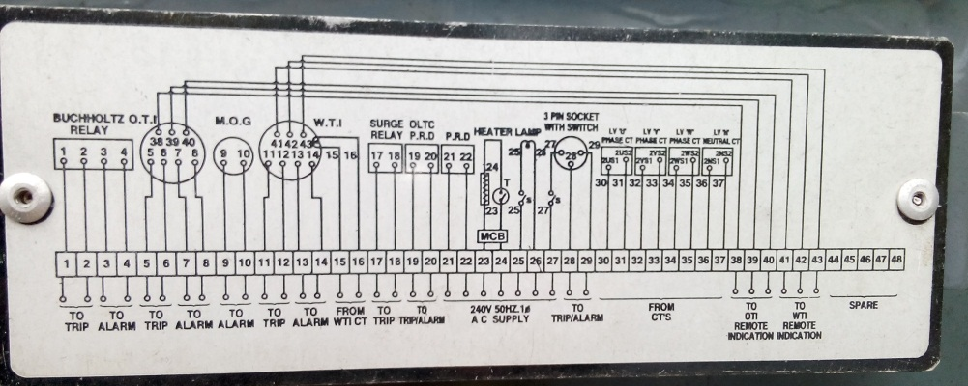

**Differential protection:**

**Generally Differential protection is provided in the transformer rated more than 5MVA. The Differential Protection of Transformer has advantages over other schemes of protection.**

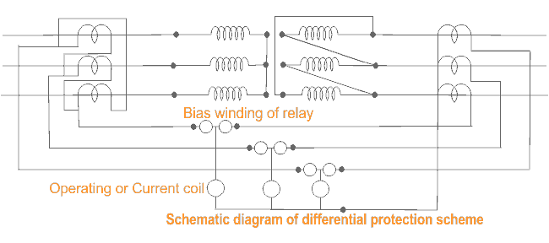

**The faults occur in the transformer inside the insulating oil can be detected by Buchholz relay. But if any fault occurs in the transformer but not in oil then it cannot be detected by Buchholz relay. Any flash over at the bushings are not adequately covered by Buchholz relay. Differential relays can detect such type of faults. Moreover Buchholz relay is provided in transformer for detecting any internal fault in the transformer but Differential Protection scheme detects the same in faster way.**

**Over current and Earth fault protection:**

**Backup protection of electrical transformer is simple Over Current and Earth Fault protection applied against external short circuit and excessive over loads. These over current and earth Fault relays may be of Inverse Definite Minimum Time (IDMT) or Definite Time type relays. Generally IDMT relays are connected to the in-feed side of the transformer.**

**The over current relays cannot distinguish between external short circuit, over load and internal faults of the transformer. For any of the above fault, backup protection i.e. over current and earth fault protection connected to in-feed side of the transformer will operate. Backup protection is although generally installed**

**Restricted earth fault protection:**

**An external fault in the star side will result in current flowing in the line current transformer of the affected phase and at the same time a balancing current flows in the neutral current transformer, hence the resultant current in the relay is therefore zero. So this REF relay will not be actuated for external earth fault. But during internal fault the neutral current transformer only carries the unbalance fault current and operation of Restricted Earth Fault Relay takes place. This scheme of restricted earth fault protection is very sensitive for internal earth fault of transformer. The protection scheme is comparatively cheaper than differential protection scheme.**

**Oil and Winding Temperature Indicator of Transformer:**

**These are generally precision instruments. A temperature indicator of power transformer is specially designed for protection of transformer in addition to its temperature indication and cooling control features. That means, this device performs three functions**

1. **These instruments indicate instantaneous temperature of oil and windings of transformer.**
2. **This also record maximum temperature rise of oil and windings.**
3. **These instruments operate high temperature alarm at a predetermined value of allowable temperature limit.**
4. **Temperature indicators of transformer can also trip the circuit breakers associated with the power transformer when the temperature of oil or winding reaches a predetermined limit.**

**WTI & OTI shall be set to operate at the following temperature:**

**Oil-Alarm-80 ℃, Trip-90 ℃**

**Wlnding-Alarm-85℃, Trip-95 ℃**

**3.5 Maintenance of sub-station equipment’s:**

* **Predictive Maintenance.**
* **Precautionary Maintenance.**

**3.5.1 Predictive maintenance:**

**Predictive maintenance is gaining popularity as a productivity tool because it helps eliminate unscheduled downtime of expensive equipment and reduce the overall cost of maintenance. This approach, sometimes called ‘condition-based maintenance’.**

**It has some advantages. They are as follows,**

1. **Reduced life cycle costs through lower maintenance costs, reduced expenditure for spare parts, and extended component life.**
2. **Maximized component life through consistent prevention of conditions that reduce the life expectancy of the equipment.**
3. **Optimized performance through loading above ‘book’ rating.**
4. **Minimized downtime through proactive repair planning based on information gained from asset monitoring.**
5. **Reduction of insurance costs by demonstrating responsible custodianship over grid assets.**
6. **Avoidance of penalties through effective prediction and prevention of equipment failures.**
7. **Environmental benefits through prevention of environmentally hazardous conditions.**

**3.6 Condition based monitoring:**

***IR thermometer for detecting hot spot:***

**The identification and the possible elimination of Hot Spots in time can safeguard many equipment in a sub-station. It helps to avoid unscheduled outages and the consequence monetary loss. Thus by prior detection of the hot spots, the sub-station is safeguarded and entire replacement of the plant components will be made obsolete. The importance of IR camera in detecting Hot spots in a high voltage substation is well established especially the impending failure of CT s.**

***Detection of PD by ultrasonic method:***

**Partial discharge (PD) is usually happened caused by flaw and deterioration of transformer insulation. It is the main reason of the accident of transformer and power system. Therefore, it's necessary and important to detect the partial discharge of transformer while operating and manufacturing. When PD of transformer internal insulation occurs, electromagnetic waves, sound waves and other signals are produced. According to supersonic signal, we can detect the location of PD. But this method cannot test the number of charge. With ultrasonic detection method, it is easy to locate PD and test the number of charge. In this paper, a method of ultrasonic detection is presented, which is based three-dimensional scatter point and ultrasonic hit to time. The method is effective to locate fault of transformer insulation.**

***Thermal imaging:***

**Most transformers are cooled by either oil or air while operating at temperatures much higher than ambient. In fact, operating temperatures of 65 C for oil-filled transformers are common. Nevertheless, problems with transformers often manifest themselves in overheating or hot spots, making thermal imaging a good tool for finding problems.**

**In oil-filled transformers, monitor the following external components**

**High and low voltage bushing connections: Overheating in a connection indicates high resistance and that the connection is loose or dirty. Also, compare phases, looking for unbalance and overloading.**

**Cooling tubes: On oil-cooled transformers, cooling tubes will normally appear warm. If one or more tubes are comparatively cool, there may be a problem.**

**Problems with surge protection and lightning arrestors leaking to ground and current tracking over insulators can also be detected using thermography and thermal imagers.**

**For thermal imaging to be effective in pinpointing an internal transformer problem, the malfunction must generate enough heat to be detectable.**

**A good approach is to create regular inspection routes that include the transformers on all essential electrical circuits. Save thermal images for comparison and references of proper operating equipment.**

***Ultra TEV Partial Discharge Detector***

**EA Technology’s Ultra TEV Partial Discharge Detector Kit detects both surface and internal discharge activity within medium voltage equipment.**

**The Ultra TEV Detector is a hand held, dual sensor, Partial Discharge detector, which enables simple first pass identification of potentially damaging HV equipment faults and MV equipment faults before they become failures.**

**3.6.1 Precautionary maintenance:**

**The precautionary maintenance activities are undertaken on the service life of the component and conducted after a failure or breakdown. Such maintenance results in outage of circuit and supply. In general, it consists of locating the trouble, repair and decommissioning.**

**Precautionary maintenance covers a wide range of activities aimed at keeping the equipment in perfect working condition for performing its function as per assigned duties. The choice of activities and schedule depends upon local requirements.**

**Inspection: This refers to the maintenance activity which comprises careful observation/scrutiny of the equipment without dismantling it. It usually includes visual and operational checks.**

**Servicing: This refers to cleaning, adjustment, lubrication and other maintenance functions without dismantling the equipment.**

**Examination: This refers to inspection with necessary dismantling, measurements and non-destructive tests to obtain data regarding the condition of components/sub-assemblies.**

**Overhaul: This refers to the work done with the objective of repairing/replacing worn-out parts and defective parts. The equipment, sub-assemblies are dismantled partly or completely. The condition of components is inspected. Dimensions of worn-out components are measured. The components worn-out beyond acceptable limit are replaced. The assembly is followed by functional checks and measurements to ensure satisfactory operation.**

**3.7 Types of Faults and Identification of different types of Faults**

**In a 33/11kV power distribution system, similar to other power systems, various faults can occur, disrupting the normal flow of electricity and causing interruptions in the supply. Some common types of faults in such a distribution system include:**

**3.7.1 Over head Transmission lines**

**In overhead power transmission lines of an 11kV feeder in a power distribution system, various types of faults can occur. These faults can disrupt the normal flow of electricity and cause interruptions in the power supply. Some common types of faults in overhead power transmission lines include:**

* **Short Circuit Fault: This occurs when two or more conductors come into contact with each other due to insulation failure or other reasons, resulting in a sudden surge of current. Short circuits can cause significant damage to equipment and may lead to power outages.**
* **Open Circuit Fault: It happens when there is a break or discontinuity in the conductor, resulting in a loss of continuity in the circuit. Open circuit faults can occur due to conductor breakage, loose connections, or damaged insulators.**
* **Phase to Ground Fault: A ground fault occurs when one of the conductors comes in contact with the ground or an unintended conducting surface. This can be due to insulation failure or physical damage to the line. Ground faults can pose safety hazards and lead to power outages.**
* **Transient Fault: These are temporary faults caused by environmental factors such as lightning, birds, or tree branches contacting the lines. They may cause momentary interruptions in power but often clear automatically once the triggering factor is removed.**
* **Intermittent Fault: These faults occur sporadically and can be challenging to detect as they may come and go unpredictably. Intermittent faults can be caused by issues like moisture, thermal expansion/contraction, or loose connections.**
* **Phase-to-Phase Fault: When two phases of the power line come into contact with each other, it results in a phase-to-phase fault. This fault can cause significant damage and disrupt the power supply.**
* **Phase-to-Phase-to-Earth Fault: This fault is a combination of phase-to-phase and phase-to-earth faults. It happens when a conductor from one phase comes into contact with another phase and then to the ground. This creates a short circuit involving two phases and the earth.**
* **Under Frequency Fault: This fault occurs when the frequency of the AC power system drops below the standard or rated frequency. It can happen due to sudden overloading, tripping of generation units, or a significant imbalance between power generation and consumption.**
* **Over Frequency Fault: Conversely, this fault occurs when the frequency of the AC power system exceeds the standard or rated frequency. It can result from sudden loss of load, tripping of generating units, or malfunctioning of control systems regulating the frequency.**
* **Mechanical Faults: Physical damage to the transmission line caused by severe weather conditions like storms, high winds, ice accumulation, or falling objects can lead to mechanical faults.**
* **Overvoltage Faults:**
  + **Switching Surges: When there's a sudden change in the electrical circuit, such as switching operations or lightning strikes, it can cause overvoltages.**
  + **Fault Clearance: In case of a fault, especially during its clearing process, temporary overvoltages can arise due to the sudden reduction in load impedance.**
  + **Lightning Strikes: Direct or nearby lightning strikes can cause significant over-voltages in the power lines.**
* **Under-voltage Faults:**
* **Voltage Drop: Long transmission lines or high power demand can lead to voltage drop along the line, causing under-voltage at the receiving end.**
* **Load Imbalance: Uneven distribution of load among different phases can cause under-voltage in some phases.**
* **Faults in the System: Short circuits or faults in transformers or other components can lead to a drop in voltage.**

**3.7.2 Fault Detection Techniques in Over-head transmission lines**

**1.** **Sequence Components Analysis:**

* **Positive, Negative, and Zero Sequence Components: In the event of a fault, the currents and voltages in the power system exhibit different components: positive, negative, and zero sequence.**
  + **Positive sequence components indicate normal balanced conditions.**
  + **Negative sequence components often arise from phase unbalances or faults.**
  + **Zero sequence components typically emerge from ground faults.**
* **Fault Detection: Monitoring these sequence components allows for the detection and classification of faults, distinguishing between different fault types (line-to-line, line-to-ground, or three-phase faults) and aiding in their location within the power distribution network.**

**2. Harmonic Analysis of Current:**

* **Harmonic Content: Faults can introduce harmonics into the current waveform.**
* **Detection through Harmonic Analysis: Continuous monitoring and analysis of harmonic content, especially unusual harmonic distortions, can indicate the presence of faults or abnormal conditions in the conductors.**
* **Equipment for Analysis: Utilizing harmonic analysis tools or devices (like spectrum analyzers or power quality meters) helps in identifying and quantifying harmonic components in the current waveform.**

**3. Phase Angle Measurement:**

* **Phase Angle Deviations: Monitoring phase angles between voltages and currents at different points in the system.**
* **Abnormal Phase Angles: Sudden or abnormal phase angle deviations can indicate faults or imbalances in the power system.**
* **Use in Fault Detection: Real-time monitoring of phase angles helps in identifying and locating faults, especially those causing phase imbalances or asymmetrical conditions in the conductors.**

**Other methods for fault detection :**

**4.Visual Inspection: Regular visual inspections of conductors and associated equipment are essential to identify any visible signs of damage, corrosion, or wear that could potentially lead to faults.**

**5. Manual Patrolling: Personnel conduct periodic patrols along the power lines to visually inspect the conductors for any physical damage, vegetation encroachment, or other anomalies.**

**6.Thermography (Infrared Inspection): This technique involves using thermal imaging cameras to detect abnormal temperatures along the conductors. Hotspots can indicate potential faults or areas of high resistance, such as loose connections or damaged conductors.**

**7. Ultrasonic Testing: Ultrasonic devices are used to detect partial discharges, arcing, or corona effects that may not be visible but can indicate potential faults in the conductors.**

**8. Power Quality Monitoring: Monitoring the quality of power transmitted through the conductors can help detect fluctuations, harmonics, or irregularities that might be indicative of faults or abnormalities.**

**9. Fault Indicators: Installing fault indicators along the power lines helps in quickly pinpointing the location of faults when they occur. These indicators react to changes in current, voltage, or other parameters and provide visible or remote signals.**

**10.Cable Testing and Diagnosis: Using cable testing methods such as time domain reflectometry (TDR), partial discharge measurements, or dielectric tests to assess the condition of the conductors and detect any insulation faults.**

**11.Fault Location Systems: Utilizing sophisticated fault location systems that combine various technologies (like impedance-based methods, traveling wave analysis, or signal processing techniques) to precisely locate faults on the conductors.**

**12.Remote Monitoring and Sensors: Installing sensors along the power lines for continuous monitoring of parameters like temperature, strain, vibration, or humidity, which can indicate potential faults or stress points.**

**13.Fiber Optic Sensors: Employing fiber optic sensors to monitor parameters such as strain or temperature along the conductors, providing real-time data for fault detection.**

**14.Smart Grid Technologies: Integrating advanced grid technologies with automated monitoring and control systems to detect faults, isolate affected areas, and reroute power for minimal disruption.**

**3.7.3 Types of Faults in Power Transformers**

**In a 33/11 kV power distribution system, various types of faults can occur in power transformers. These faults can broadly be categorized into electrical, mechanical, and chemical faults.**

1. **Electrical Faults:**
   * **Core Faults: These include issues such as core insulation breakdown or core laminations becoming damaged, leading to increased core losses and potential short circuits.**
   * **Winding Faults: These faults involve issues within the transformer windings, such as short circuits or open circuits in the windings, leading to imbalances and potential overheating.**
   * **Over Flux and Under Flux: Over flux occurs when the magnetic flux in the core exceeds the design limits, causing saturation and potential overheating. Under flux, on the other hand, indicates insufficient magnetic flux, leading to lower efficiency.**
   * **REF (Restricted Earth Fault): A type of fault protection system that detects earth faults within the transformer windings.**
   * **Differential Relay Faults: Differential relays are used for protection against internal short circuits or faults within the transformer windings. Faults in the relay system can lead to ineffective protection.**
   * **Open Circuit Faults: These faults involve interruptions in the electrical circuit, potentially leading to a loss of power transmission or abnormal operation.**
2. **Mechanical Faults:**
   * **Mechanical Failure: This includes issues such as physical damage to the transformer due to external forces, manufacturing defects, or wear and tear over time.**
   * **Cooling System Failure: Problems with the cooling system, like a malfunctioning fan or cooling oil circulation issues, can lead to overheating.**
   * **Vibration and Noise: Excessive vibration or abnormal noise can indicate mechanical issues within the transformer.**
3. **Chemical Faults:**
   * **Insulation Deterioration: Chemical reactions or contamination can degrade the insulating materials, reducing their effectiveness and leading to potential short circuits or breakdowns.**
   * **Oil Contamination: Contamination of transformer oil due to moisture, particulates, or chemical reactions can degrade its dielectric properties, affecting transformer performance.**

**3.7.4 Fault detection techniques in power transformers**

* **Mechanical Faults:**

1. **Core Faults:**
   * **Partial Discharge (PD) Monitoring: Continuous monitoring of partial discharges within the transformer core to detect insulation breakdown or faults.**
   * **Core Ground Detection Relays: Devices that detect any ground faults occurring within the transformer core.**
2. **Winding Faults:**
   * **Winding Temperature Monitoring: Thermocouples or resistance temperature detectors (RTDs) to monitor winding temperatures for any abnormal rise indicating faults.**
   * **Differential Relay Protection: Detects internal short circuits or winding faults by comparing the current entering and leaving the transformer windings.**
   * **Bushings and Tap Changer Monitoring: Regular checks on bushings and tap changers for any signs of damage or abnormal operation indicating winding faults.**
3. **Flux-related Faults:**
   * **Buchholz Relay: Detects internal faults such as overflux or underflux conditions by monitoring gas accumulation in the transformer oil.**
   * **Magnetic-Inductive Sensors: Measure and monitor magnetic flux densities to identify overflux or underflux situations.**
4. **Voltage Regulation (REF) Faults:**
   * **Voltage Regulator Monitoring: Regular inspection and testing of voltage regulator components to ensure proper functioning and avoid REF-related issues.**
5. **Open Circuit Faults:**
   * **Transformer Turns Ratio (TTR) Tests: Conducted periodically to detect any open circuit faults or issues with the transformer windings.**
   * **Low Resistance Ohmmeter (DLRO) Tests: Used to measure winding resistance and detect any open circuits.**

* **Mechanical Faults:**
  + **Visual Inspection: Regular visual checks for physical damage, corrosion, loose connections, or oil leaks.**
  + **Vibration Monitoring: Use vibration sensors to detect mechanical issues or abnormalities.**
* **Chemical Faults:**
  + **Dissolved Gas Analysis (DGA): Analyzes gases dissolved in transformer oil to detect and identify potential incipient faults or abnormal conditions.**
  + **Oil Quality Monitoring: Regular testing of transformer oil for moisture content, acidity, and other parameters to ensure proper insulation and prevent chemical degradation.**

**3.8 Single line diagram**

**A single-line diagram (SLD) is a simplified representation of an electrical power system or network. It's called a "single-line" diagram because it uses a single line to represent the conductors or electrical components, showing how they are interconnected without getting into the detailed physical layout.**

**During my training period in WBSEDCL ,I have visited two 33/11kv substation where I have practically learnt the functionalities of various components of a substation .**

**1. Liluah Substation**

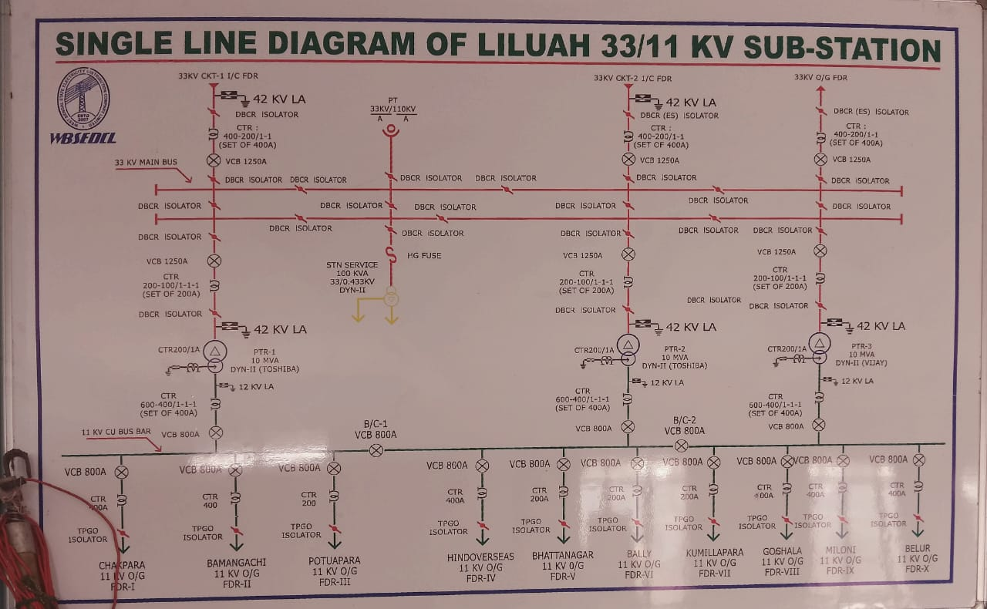

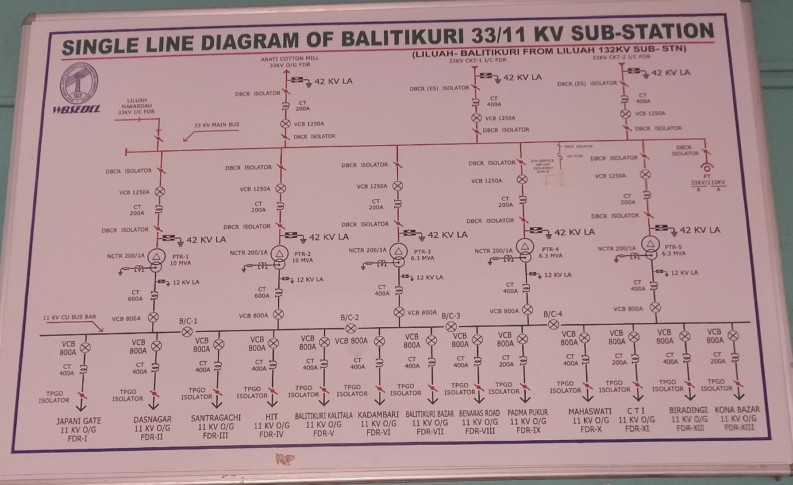**2. Balitikuri Substation**

**Unit 4: Future Prospect**

1. **Integration of Smart Grid Technologies: The integration of smart grid technologies was ongoing to enhance the efficiency, reliability, and flexibility of the power distribution network. SCADA systems were being upgraded to accommodate these technologies, including advanced metering infrastructure (AMI), distribution automation, and demand response systems.**
2. **Enhanced Monitoring and Control Capabilities: SCADA systems were being equipped with more advanced monitoring and control capabilities. This involved real-time data acquisition from various field devices, sensors, and smart meters to provide better visibility and control over the distribution network.**
3. **Improved Communication Infrastructure: Upgrades in communication infrastructure, including the implementation of robust communication protocols, were underway. This was crucial for seamless data exchange between field devices, substations, control centers, and other components of the power system.**
4. **Cybersecurity Measures: With increased digitalization and connectivity, ensuring cybersecurity became a paramount concern. SCADA systems were being fortified with enhanced cybersecurity measures to protect against cyber threats and ensure the integrity and confidentiality of the data and control commands transmitted within the system.**
5. **Integration of Renewable Energy Sources: Considering the growing integration of renewable energy sources like solar and wind into the distribution grid, SCADA systems were being adapted to efficiently manage these distributed energy resources (DERs). This included improved forecasting, monitoring, and control functionalities to handle the variability and intermittency of renewable generation.**
6. **Data Analytics and AI Applications: There was a trend towards leveraging data analytics, machine learning, and artificial intelligence (AI) techniques within SCADA systems. These technologies were used for predictive maintenance, fault detection, load forecasting, and optimizing grid operations.**
7. **User Interface and Accessibility: Upgrades to the user interface of SCADA systems were aimed at providing more intuitive dashboards and user-friendly interfaces for operators and engineers to efficiently monitor and manage the distribution network.**

**Unit 5: Data Analysis of Energy consumption of 33/11kv Liluah Substation**

**The WBSEDCL Liluah 33/11kv Substation has 8 11kv feeder which supply electricity for domestic, industrial, agricultural, commercial, administrative offices, and other purposes. Eight 11 kv Feeders name-**

**1) Kumillapara & Bamangachi**

**2) Chakpara**

**3) Bhattanagar**

**4) Hind-Overseas& Gosala**

**5)Bally**

**6)Belur**

**7)Patuapara**

**8)Miloni**

**I have been provided with an annual data consumption of Liluah substation and I have derived few conclusions based on statistical analysis of the data provided.**

**For the data analysis I have used Python programming language and its 4 important library**

**1.*Numpy***

***2.Pandas***

***3.Matplotlib***

***4.Seaborn***

***Data Analysis involves 4 important stages:***

***Data Cleaning: Data obtained is always not suitable for direct analysis purpose. We have to handle missing,null values,drop/remove some unwanted/unnecessary rows/columns for making data clean and ready for further analysis.***

***Data Exploration(EDA): Data obtained has to be further analysed in order to draw some meaningful insights which will eventually help in drawing accurate predictions from the data.***

***Data Viusulization: Relations between different rows and coloumns of a data can be drawn more clearly and vividly by adopting various data visualization techniques.It involves plotting values in barplot, scatter plot, piechart etc.***

***Prediction Analysis: From the above 3 stages the relation between different columns and data hence incurred is used for accurate prediction from the data.***

**The entire analysis is provided in the following github link.**

**1. From the given Tariff Class provided we obtained the**

**total number of different types of customers that avail electricity from WBSEDCL**

**For example : A(DM-R)-Domestic Rural has different**

**tariff from A(DM-U)- Domestic urban.**

**From the graph given we can see that in Liluah Substation ,**

**WBSEDCL has a larger population of customers which lies in rural areas and electricity is mostly for domestic purpose.**

**Hence, there is a need to increase in customer base in urban area for different purpose-domestic, urban, agriculture,etc. It should**

**improve its customer service quality , since in urban area**

**competition with private companies increase, hence ,strategical**

**approach of increasing number of 11 kv feeders, improving the**

**customer service, advertisement or development of new substations has to be adopted, hence diversifying its reach to different**

**locations.**

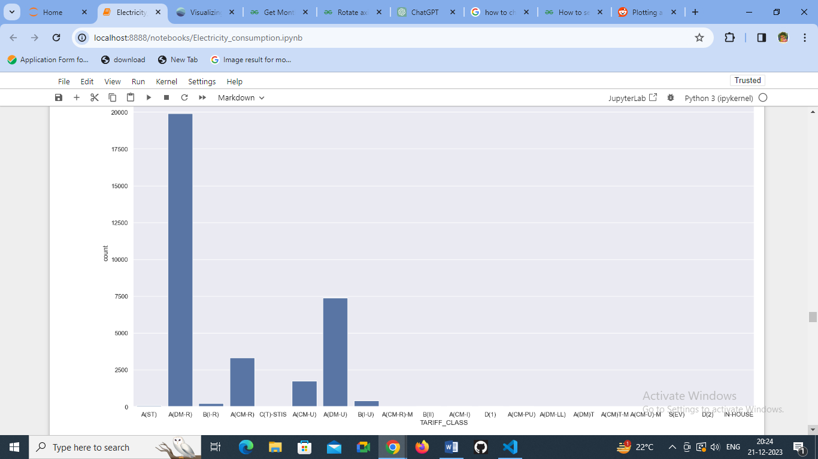

**2. Analysis of overall trends in electricity consumption over time (month)**

**Here from the bar graph 2 conclusions are incurred:**

* **Over time(month) ,the electricity consumption seems to decrease .The load seems to be maximum in the month of February as determined by Electronic Meter and least in the month of September –October. It is expected to follow the same order in future too.**
* **From this we can predict that during seasons of summer electricity consumption is high as compared to that of winter except for the February month which can be taken as an exception. It may arise due to many unavoidable conditions including environmental conditions.**
* 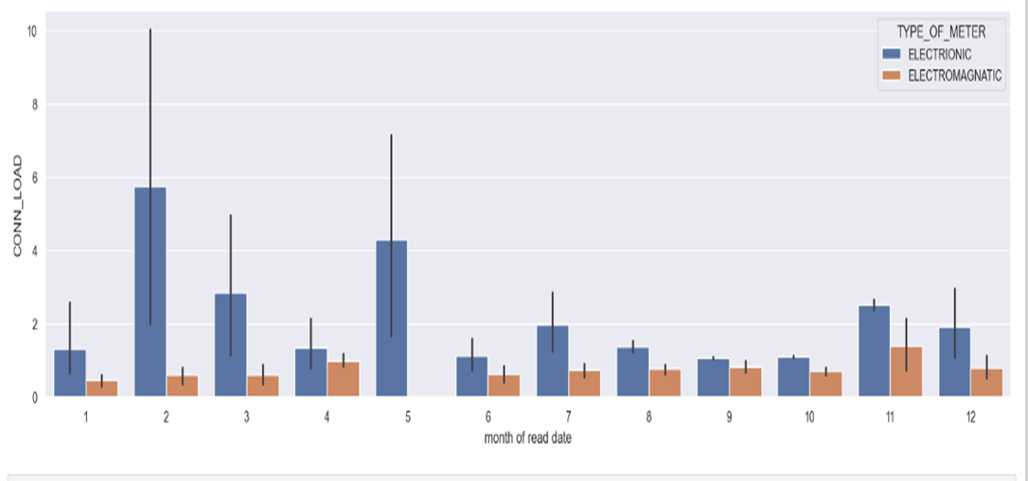**Secondly, the accuracy of electronic motors over electromagnetic motors can be clearly visualized by the graph.Since the variation of electricity consumption over time can be seen more vividly in electronic meters.**

**3.Analysis of different customer segments or types (residential, commercial, industrial) contributing to overall consumption**

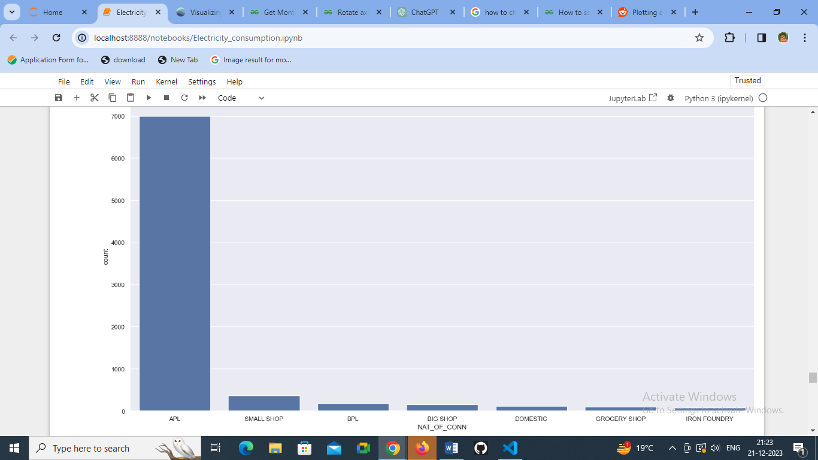

**From above graph it is obtained APL consumers are maximum and then followed by small shop, bpl ,big shop etc.**

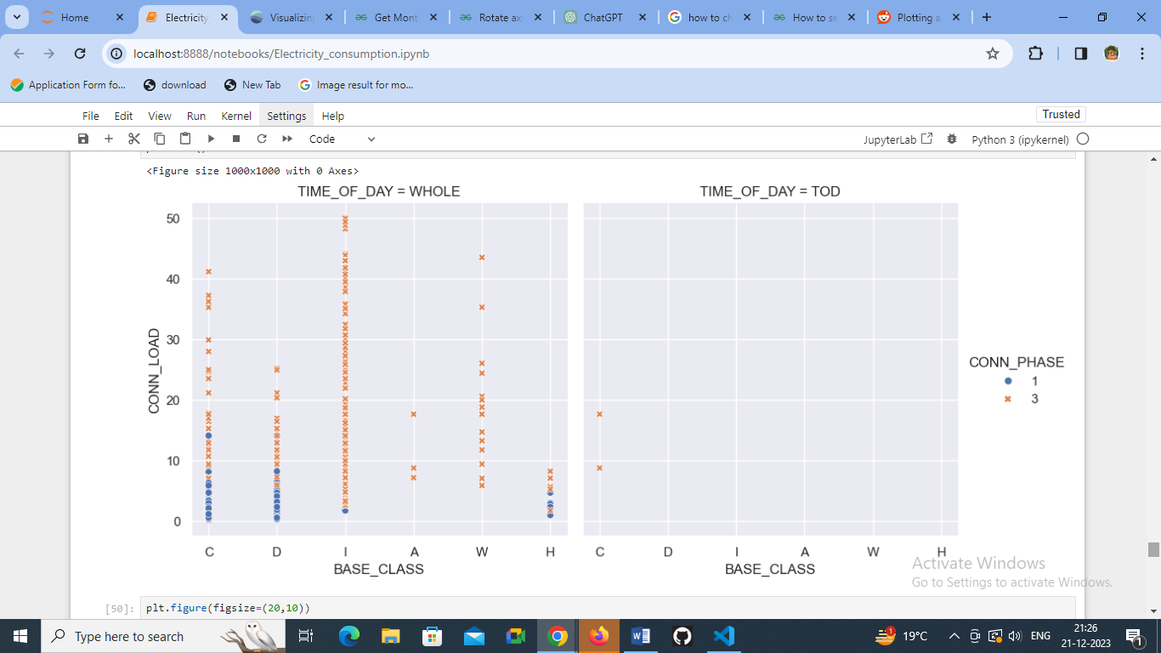

**From the graph, we can obtain significant variation of customer class with electricity consumption with maximum obtained by Industries followed by Commercial, Domestic ,etc.**

**It all shows the variation of consumption with time of day**

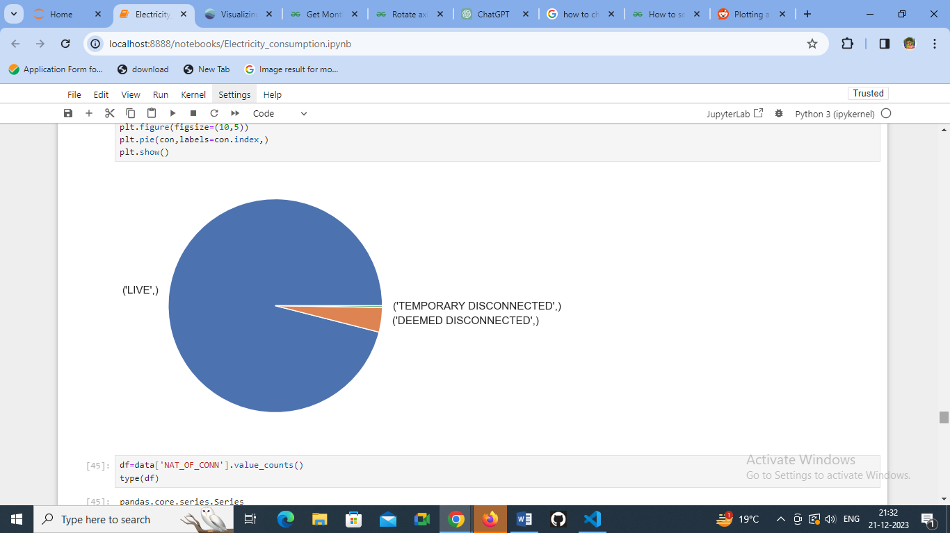**It also shows which customer segment require 3 phase and which require 1 phase supply**

**From the graph we can also analyse the customers whose connection is temporarily,live,and permanently disconnected.**

**So it can be predicted that industries consume more energy hence the customer segment including industries and other commercial spheres should be increased by reducing tariff, and providing them extra benifites so as to improve the customer base and hence the income.**

**4. Analysis consumption of energy with billing and cost structures**

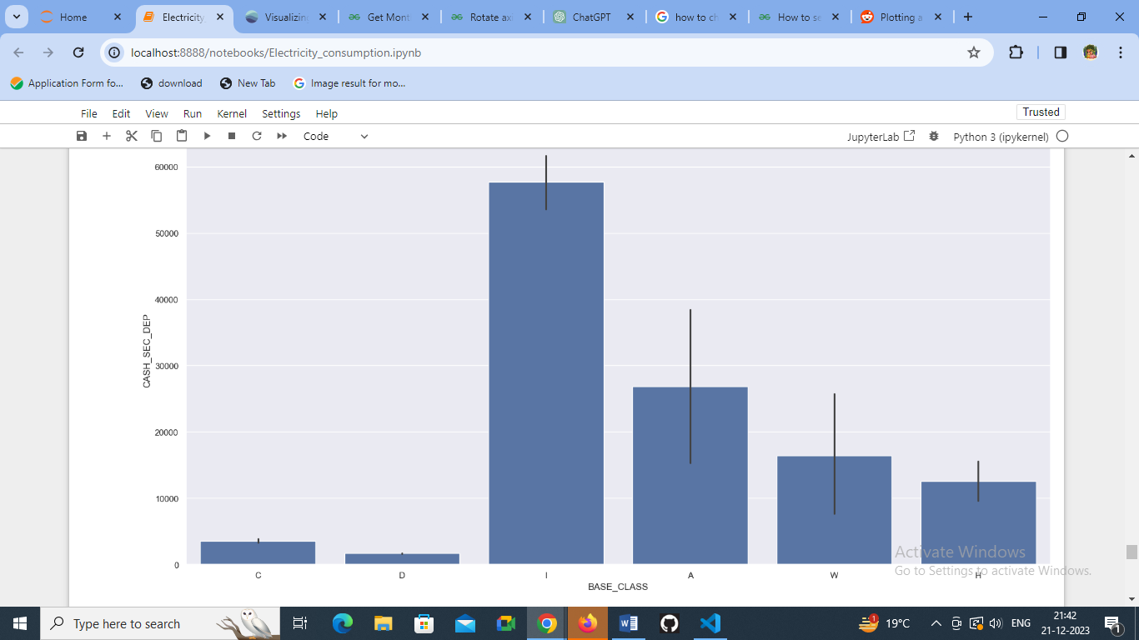

**As said industries have large energy consumption and hence higher will be the income. So it can be predicted that industries consume more energy hence the customer segment including industries and other commercial spheres should be increased by reducing tariff, and providing them extra benifites so as to improve the customer base and hence the income.**

**Hence from the graph below, shows the outstanding dues with respect to customer segment and hence it can be concluded that more benefits in terms of tariff should be given to industries because it is more beneficial**

**Secondly, government offices has more outstanding dues.**

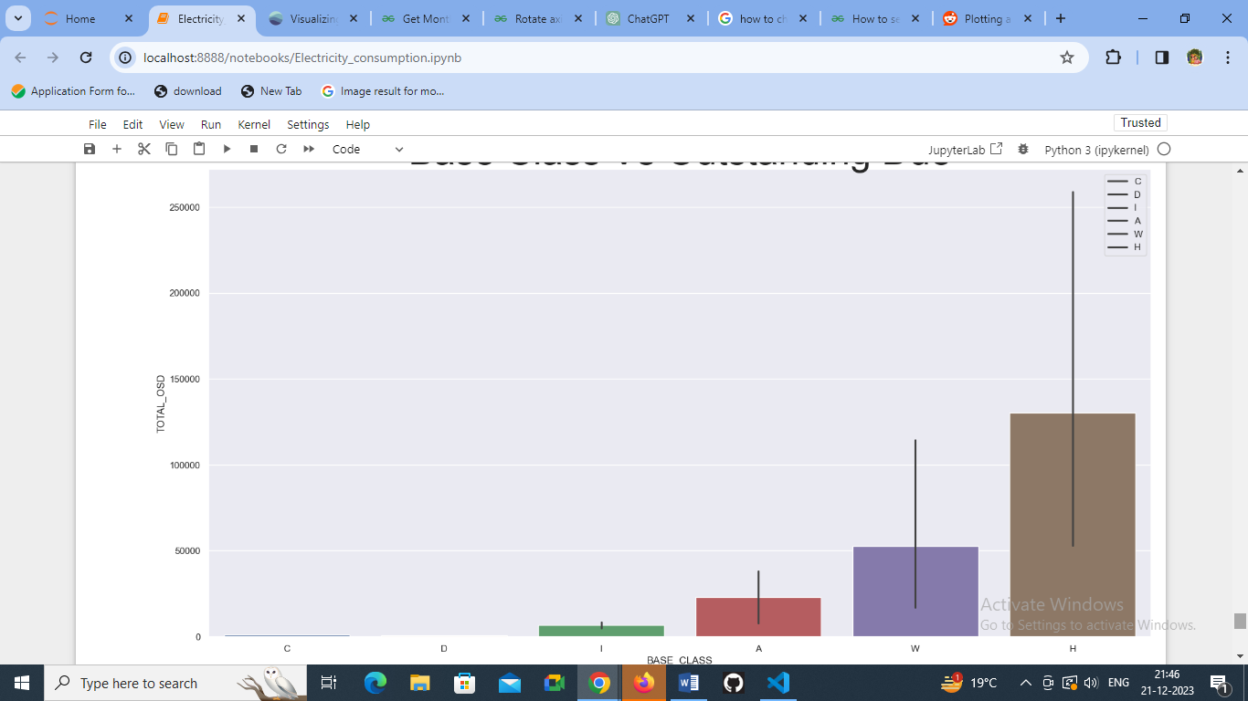

**Conclusion**

**The project focused on the design/construction/upgrade/analysis (specify the specific focus) of a 33/11 kV substation, aiming to enhance the reliability, efficiency, and performance of the electrical distribution system. Through comprehensive research, analysis, and implementation, several significant conclusions and outcomes have been realized:**

* **Enhanced Infrastructure: The design/construction/upgrade of the 33/11 kV substation has resulted in a more robust infrastructure, capable of meeting the growing demands of the distribution network.**
* **Improved Reliability: The project has contributed to increased system reliability by implementing advanced equipment, modern technologies, and enhanced protection mechanisms. This aids in minimizing downtime and ensuring uninterrupted power supply.**
* **Voltage Regulation and Power Quality: Efforts were made to regulate voltage levels and maintain power quality within acceptable limits. Measures such as capacitor banks or other reactive power compensation methods have been implemented to enhance overall system stability.**
* **Environmental Considerations: Emphasis was placed on environmental sustainability by adopting eco-friendly practices and complying with relevant regulations to minimize the ecological impact of the substation's operations.**
* **Safety Measures: Stringent safety protocols and measures were incorporated to ensure the well-being of personnel, adhering to industry standards and guidelines.**
* **Future Recommendations: To further improve the substation's performance, future recommendations include exploring renewable energy integration, advanced grid technologies, predictive maintenance strategies, and continuous monitoring for system optimization.**
* **Optimized Operations: Through the integration of automation, SCADA systems, and smart technologies, the operational efficiency of the substation has been significantly improved. Real-time monitoring, fault detection, and remote control capabilities have streamlined operations and response times.**

**In conclusion, the successful completion of the 33/11 kV substation project has contributed significantly to the enhancement of the electrical distribution network. It stands as a testament to the collaborative effort, technical expertise, and commitment to innovation in ensuring a reliable and efficient.**

**Bibliography**

**1.** **Transient Recovery Voltages in Vacuum Circuit Breakers Generated by the Interruption of Inrush Currents of Large Motors A. Borghetti, F. Napolitano, C.A. Nucci, M. Paolone, M. Sultan, N. Tripaldi**

[**https://www.ipstconf.org/papers/Proc_IPST2011/11IPST035.pdf**](https://www.ipstconf.org/papers/Proc_IPST2011/11IPST035.pdf)

**2. Protection and Switchgear-** **Bhavesh Bhalja,** **R.P. Maheshwari, Nilesh G. Chothani**

[**https://india.oup.com/productPage/5591038/7421214/9780199470679**](https://india.oup.com/productPage/5591038/7421214/9780199470679)

**3. Wikipedia**

**4.** [**http://www.edgefx.in/electrical-engineering-substation-components-and-their-workings/**](http://www.edgefx.in/electrical-engineering-substation-components-and-their-workings/)

**5.** [**http://www.electrical4u.com/electrical-circuit-breaker-operation-and-types-of-circuit-breaker/**](http://www.electrical4u.com/electrical-circuit-breaker-operation-and-types-of-circuit-breaker/)

**6.**[**http://ewh.ieee.org/soc/pes/newyork/NewSite/PDFs/Protection%20Related/TransformerProtection.pdf**](http://ewh.ieee.org/soc/pes/newyork/NewSite/PDFs/Protection%20Related/TransformerProtection.pdf)

**7.**[**http://www.circuitstoday.com/working-of-relays**](http://www.circuitstoday.com/working-of-relays)

**8.**[**http://www.electrical4u.com/electrical-insulator-insulating-material-porcelain-glass-polymer-insulator/**](http://www.electrical4u.com/electrical-insulator-insulating-material-porcelain-glass-polymer-insulator/)

**9.**[**http://www.cea.nic.in/reports/articles/god/guidelines_shunt_cap_dist_meters_cables/chap14.pdf**](http://www.cea.nic.in/reports/articles/god/guidelines_shunt_cap_dist_meters_cables/chap14.pdf)

**10.**[**http://www.wbsedcl.in/irj/go/km/docs/internet/webpage/techspec/TECH.SPEC.-ACSR.pdf**](http://www.wbsedcl.in/irj/go/km/docs/internet/webpage/techspec/TECH.SPEC.-ACSR.pdf)

**11.**[**http://www.electricalpowereducation.com/operations-maintenance/distribution-transformer-protection**](http://www.electricalpowereducation.com/operations-maintenance/distribution-transformer-protection)

**12.**[**http://www.electrical-engineering-portal.com/download-center/.../power-substations**](http://www.electrical-engineering-portal.com/download-center/.../power-substations)